Executive Headteacher:
John Grove
Headteacher:
Séana Henry
Deputy Headteachers:
Luke Redman
Suzette Coleman

Wix's Lane, Clapham Common North Side, London SW4 OAJ
Tel: 020 7228 3055 Fax: 020 7978 4942 Email: admin@wix.wandsworth.sch.uk

Belleville Wix Academy Uniform List

- Red or Blue v-neck sweatshirt or cardigan (available online)
- Bottoms: Navy Blue/Black skirts, pinafore, trousers or shorts - can be purchased externally ie: Tesco, Asda, Marks & Spencer.
- Tights: Navy Blue/Black
- Shoes: Plain black sensible shoes (velcro shoes for Nursery and Reception class)
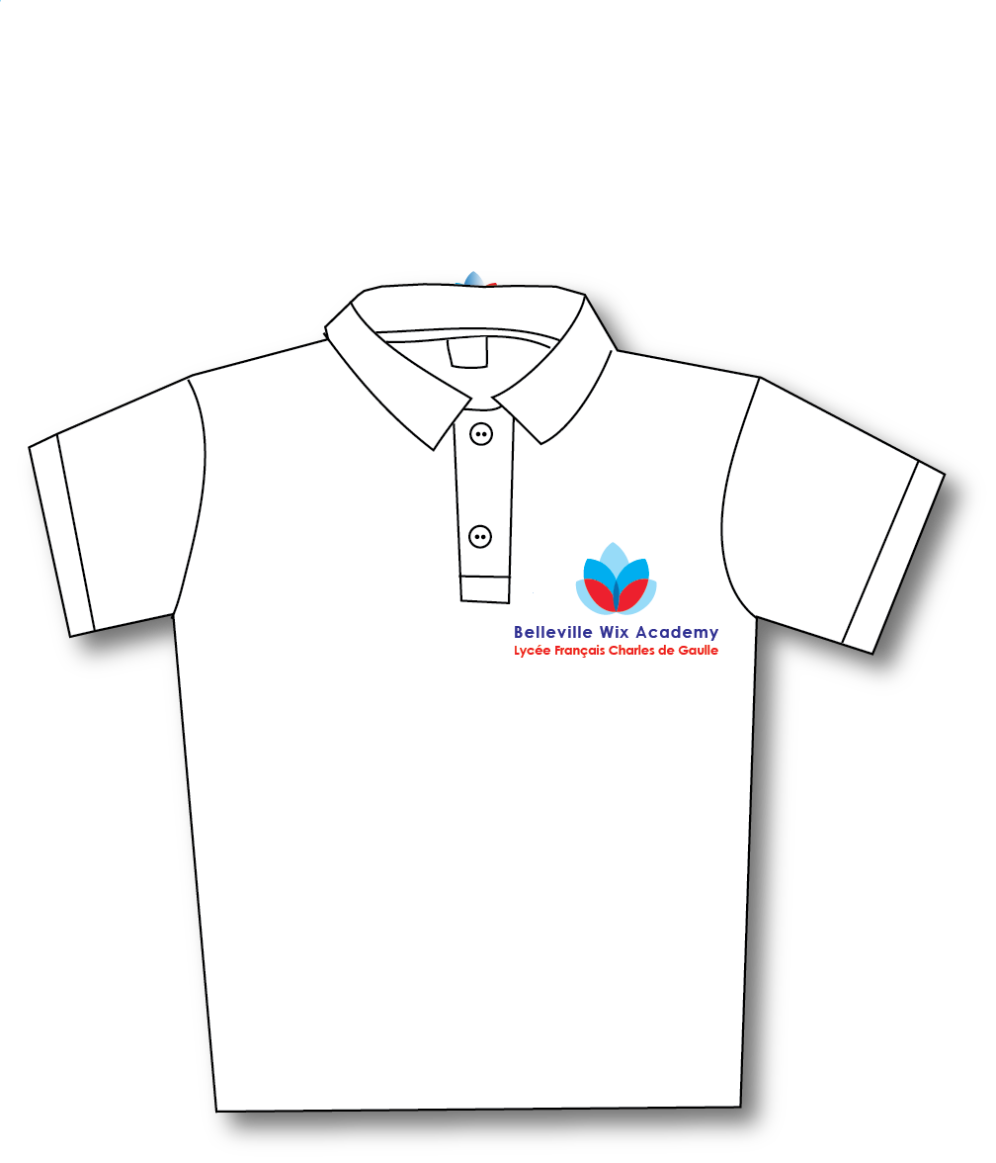
- Summer: Red or Blue Gingham Dress, Navy Blue/Black shorts - can be purchased externally ie: Tesco, Asda, Marks & Spencer.
- PE Kit: Logo T- Shirt, Navy blue shorts (available online) with plain black or white trainers/plimsolls (velcro for Nursery and Reception class)
- Book bag (available online)
- Kindly label all items of uniform.
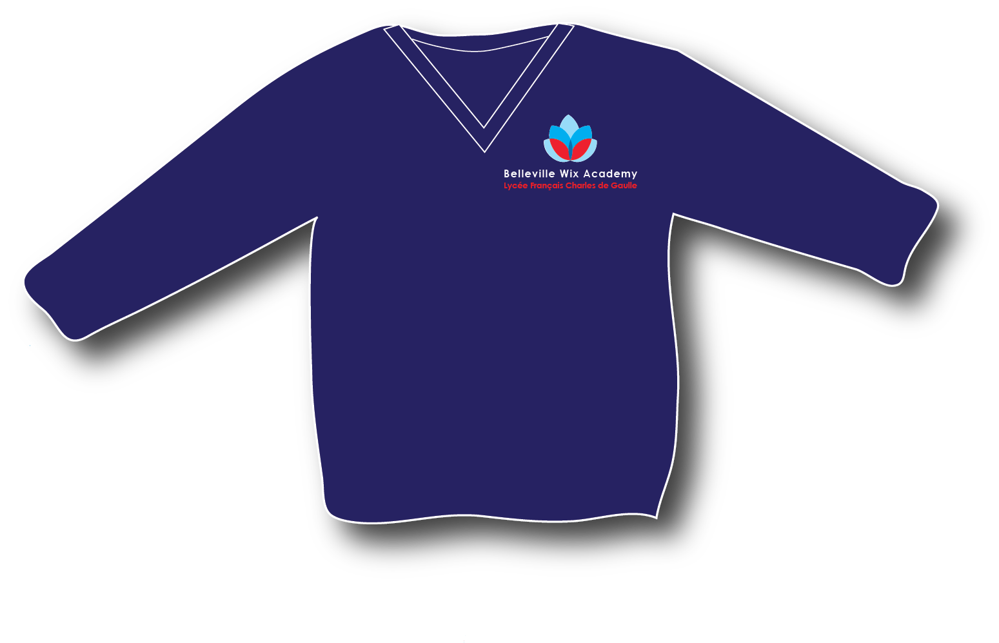
- Payable by credit/debit card www.schoolgateway.com items will be taken to your child’s classroom.

