Executive Headteacher:
John Grove
Headteacher:
Séana Henry
Deputy Headteachers:
Luke Redman
Suzette Coleman

Wix's Lane, Clapham Common North Side, London SW4 OAJ
Tel: 020 7228 3055 Fax: 020 7978 4942 Email: admin@wix.wandsworth.sch.uk

Belleville Wix Academy Uniform List

Main Uniform
- White polo shirt with school logo – long or short sleeve (available online)
- Red or Blue v-neck sweatshirt or cardigan with school logo (available online)
- Bottoms: Navy Blue skirts, pinafore, trousers or shorts - can be purchased externally ie: Tesco, Asda, Marks & Spencer.
- Tights: Navy Blue
- Summer: Red or Blue Gingham Dress, Navy Blue shorts - can be purchased externally ie: Tesco, Asda, Marks & Spencer
- Plain black sensible shoes (velcro shoes for Nursery and Reception class)
- Book bag or rucksack with school logo (available online)
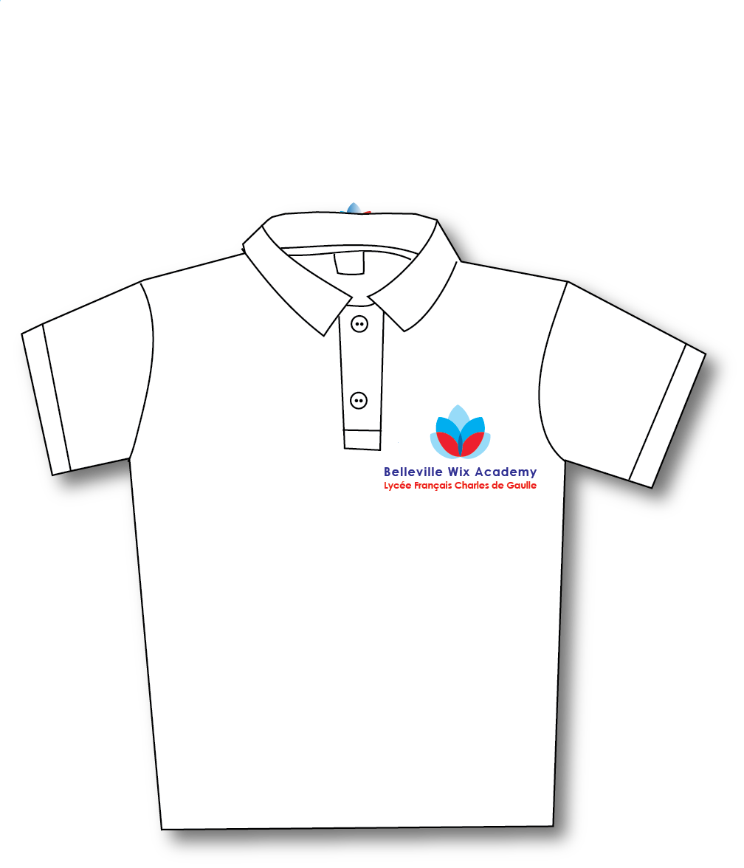
PE Kit
- Red or Blue T- Shirt and navy blue shorts with school logo (available online)
- Plain black or white trainers or plimsolls (velcro for Nursery and Reception class)

Kindly label all items of uniform with your child’s/children’s name.

