Executive Headteacher:
John Grove
Headteacher:
Séana Henry
Deputy Headteachers:
Luke Redman
Suzette Coleman

Wix's Lane, Clapham Common North Side, London SW4 OAJ
Tel: 020 7228 3055 Fax: 020 7978 4942 Email: admin@wix.wandsworth.sch.uk

Belleville Wix Academy Uniform List

- Bottoms: Navy Blue/Black skirts, trousers or shorts - can be purchased externally ie: Tesco, Asda, Marks & Spencer.
- Tights: Navy Blue/Black
- Shoes: Plain black sensible shoes (velcro shoes for Nursery and Reception class)
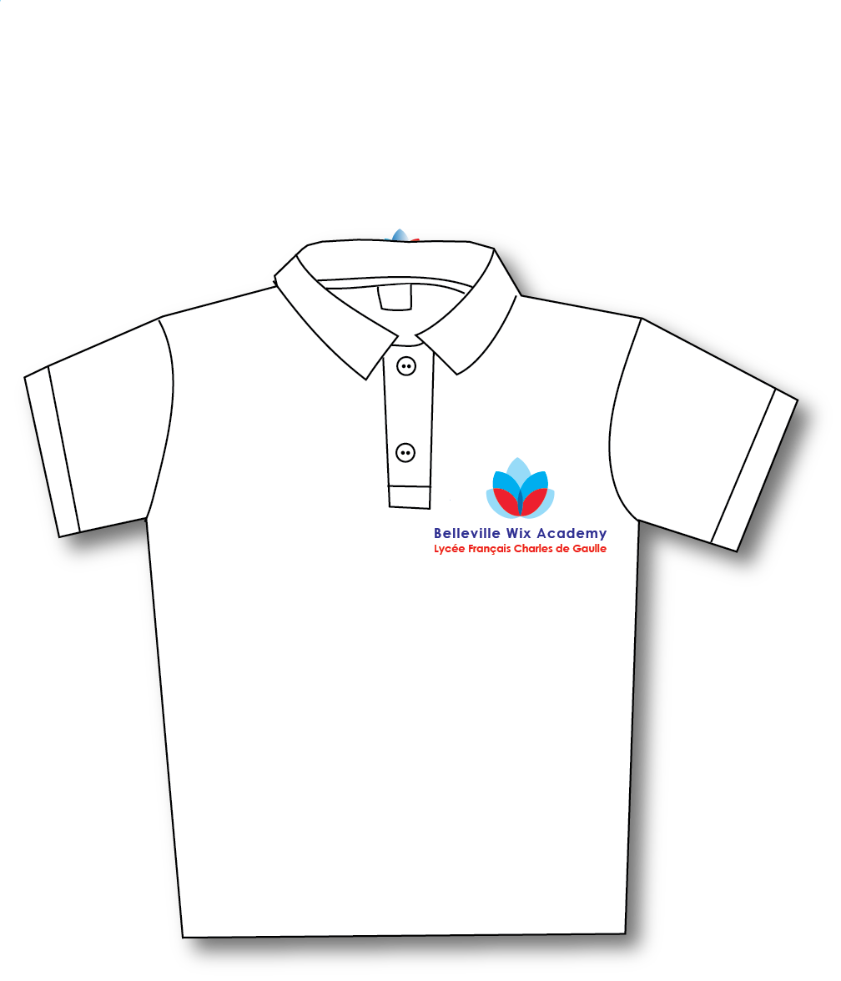
- Summer: Red or Blue Gingham Dress, Navy Blue/Black shorts - can be purchased externally ie: Tesco, Asda, Marks & Spencer.
- Kindly label all items of uniform.
If your child is eligible for Free School Meals, you will be entitled to some uniform free of charge. Please complete the Free School Meal application form.
Available online at schoolgateway.com

