

**Year 6 Trip to Winston Churchill’s War Rooms 2018-19**

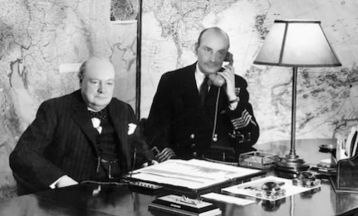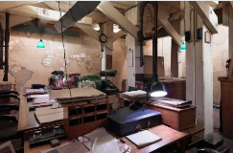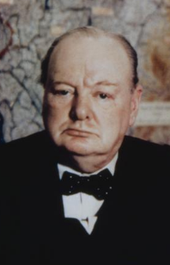

During the visit, we listened to an audio about what life was like in the Cabinet Rooms.

In the autumn term, Year 6 had the opportunity to visit Winston Churchill’s War Rooms for their topic - What were the changes to Britain during World War II?

Year 6 were able to use their knowledge and understanding from the museum trip to write fantastic Churchill biographies.