

**Year 5B Trip to The Royal Greenwich observatory 2018-19**

In the Spring Term, Year 5B had the opportunity to visit the Royal Greenwich Observatory to explore the Solar System.

They particularly enjoyed visiting the planetarium where they were given a virtual tour through space!

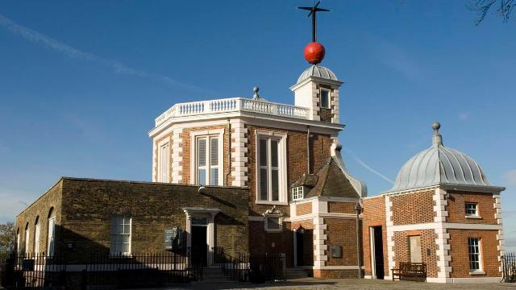[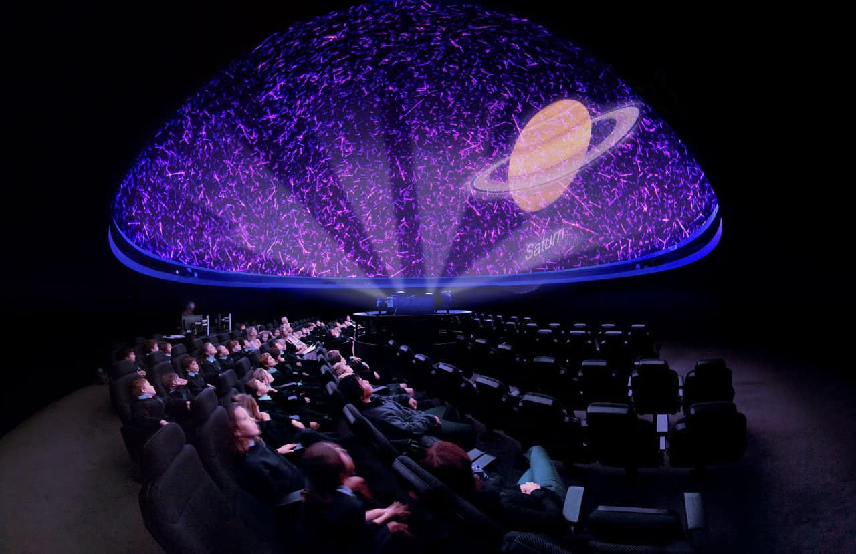](http://www.google.co.uk/url?sa=i&rct=j&q=&esrc=s&source=images&cd=&cad=rja&uact=8&ved=2ahUKEwjh7qrVrPzhAhX6D2MBHXzFCv8QjRx6BAgBEAU&url=http://www.visitgreenwich.org.uk/business/the-peter-harrison-planetarium/&psig=AOvVaw1uEl4NQSagFfbivbJYxOv_&ust=1556869397776119)[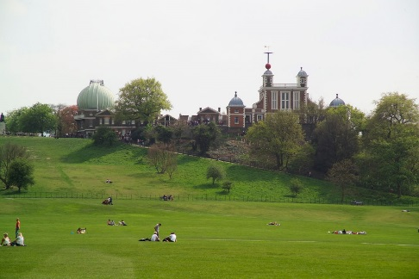](https://www.google.com/url?sa=i&rct=j&q=&esrc=s&source=images&cd=&cad=rja&uact=8&ved=2ahUKEwiHorbr1_rhAhWlz4UKHTo9A_YQjRx6BAgBEAU&url=https://www.royalparks.org.uk/parks/greenwich-park/things-to-see-and-do/the-royal-observatory&psig=AOvVaw3WGg_dygizHtLuDHSFZT99&ust=1556812278194484)

The children were thrilled to meet astronomers, exploring big ideas about the solar system through cutting-edge science.