

**Reception Mother’s Day 2018-19**

**Year 5B Art Day 2019**

5B spent the day learning a variety of techniques to create their very own portraits of Elizabeth I.

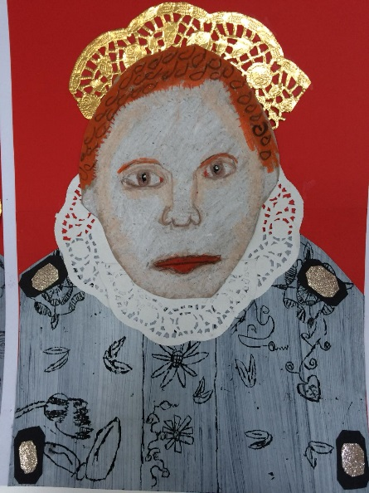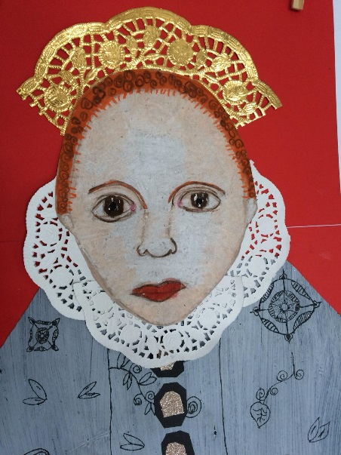

By following a step-by-step process, we created some beautiful portraits as well as sewing a Tudor roses.

We used mixed materials to make our portraits including pencil, wax crayons and paper and card as well.

