

**Reception Mother’s Day 2018-19**

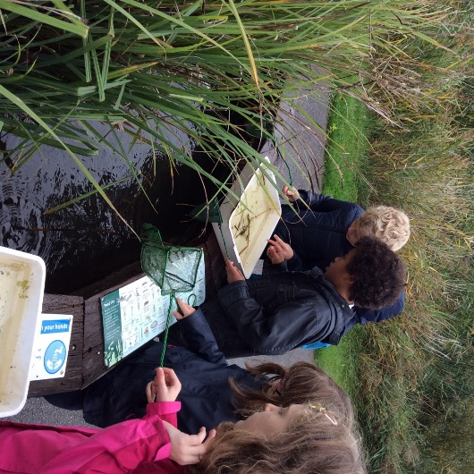**4B Trip to the Wetlands Centre 2019-20**

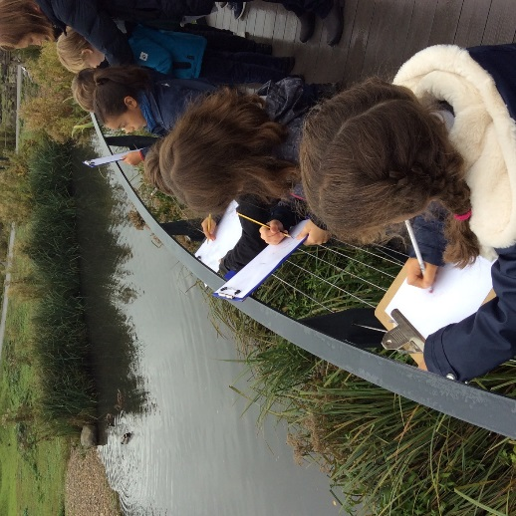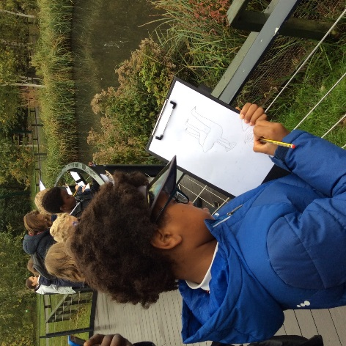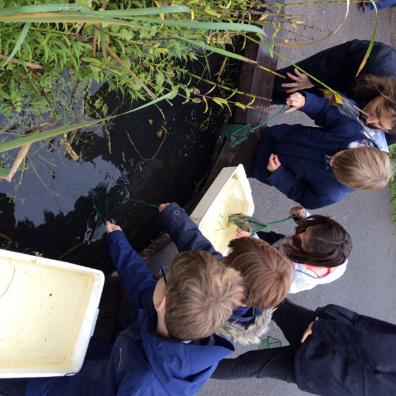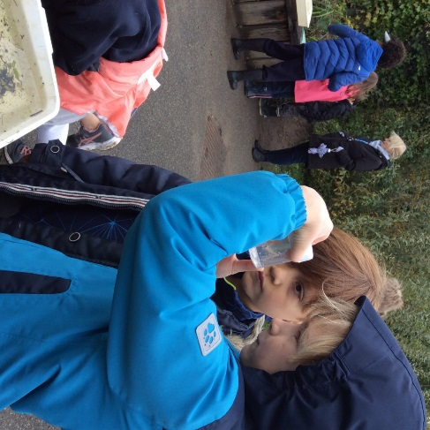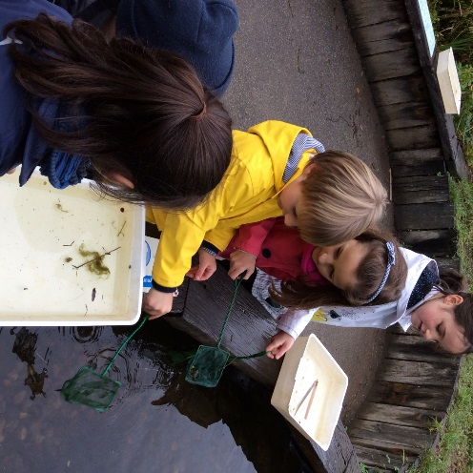

We also took our sketch books and made observational drawings of the swans, ducks and gulls!

We learned about metamorphosis when a creature changes its appearance. Frogs and insects look different when they are babies to when they are adults. They eat different things and they even breathe differently!

We enjoyed our pond dipping session where we collected pond creatures with our nets. We observed them and identified them. We recorded our findings and then shared our findings with the other groups.

4B have been learning about life cycles in Science. We went to the London Wetlands Centre to learn more about pond creatures and their life cycles.