

**Year 4 Trip to The London Wetlands Centre**

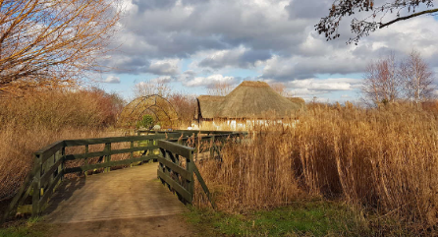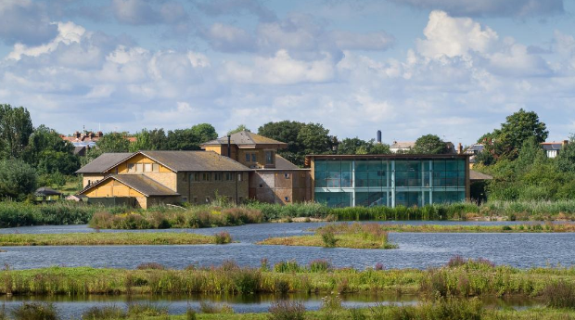**2018-19**

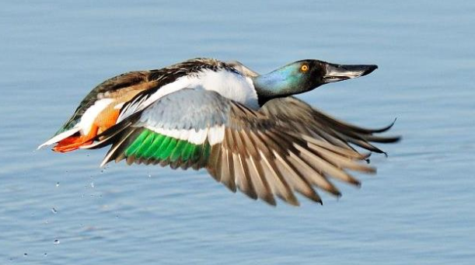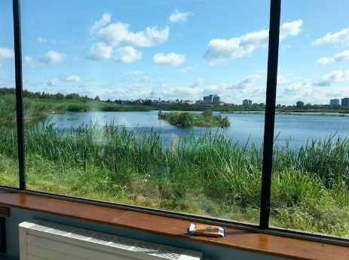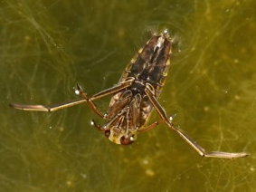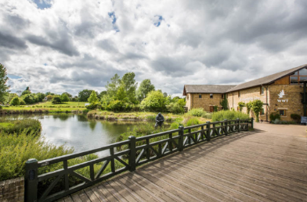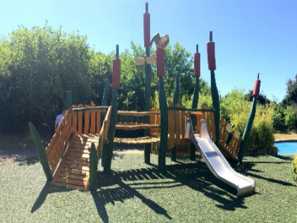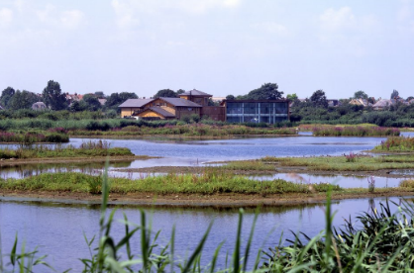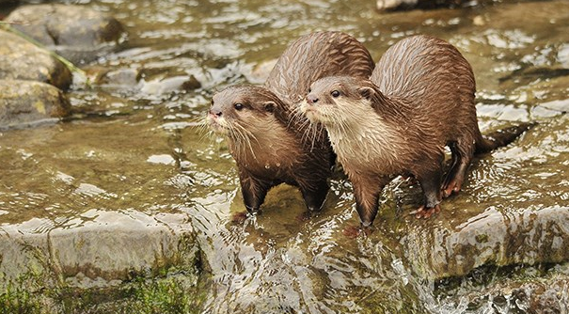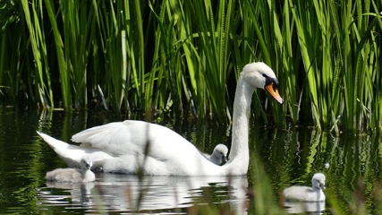

On Thursday 28th March, to enhance our learning of our summer topic about habitats, Year 4 went to visit the London Wetlands Centre.

As a class, we took part in a pond dipping workshop focusing on the different micro-habitats and animals that lived in a pond. We then had an opportunity to explore the Wetlands Centre in small groups before a well needed break for lunch.

After lunch, we had a long run around in the adventure playground before getting back on the mini buses to arrive back just in time for the Mother’s day afternoon tea.