

**Reception Mother’s Day 2018-19**

**3B British Museum Trip 2018-19**

We have been studying Ancient Egypt. At the British Museum we saw examples of Egyptian writing, hieroglyphs.

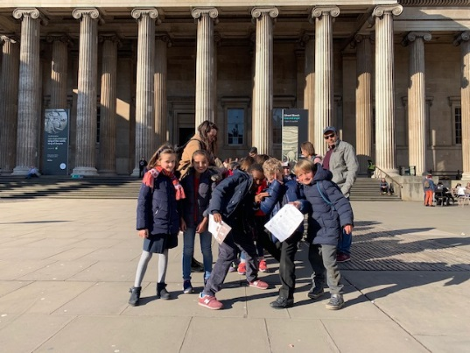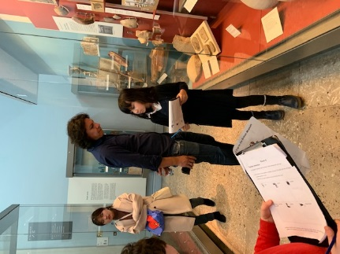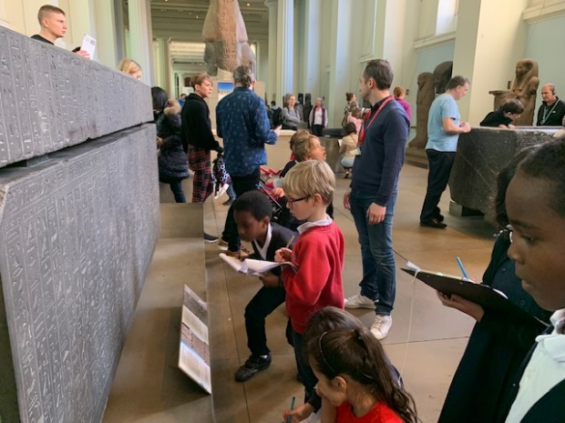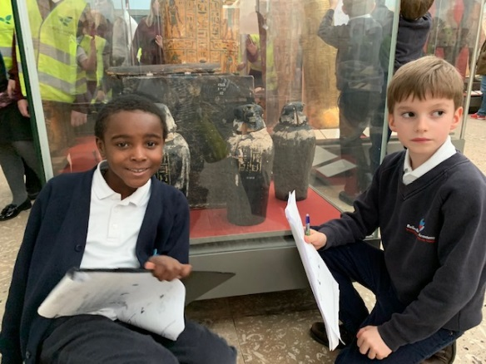

We learned so much from the exhibits. We filled out a quiz sheet as we went round, so we could show what we had seen and understood.

In class we learned how Egyptians embalmed their dead Pharoahs. At the museum we saw real canopic jars which contained organs!