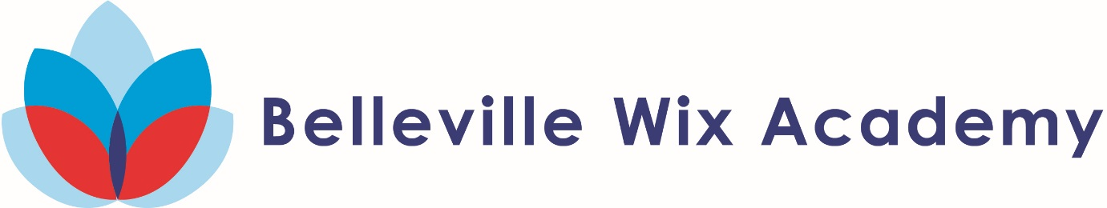

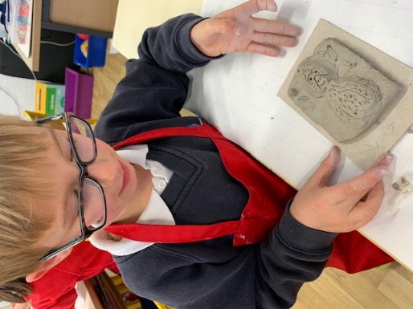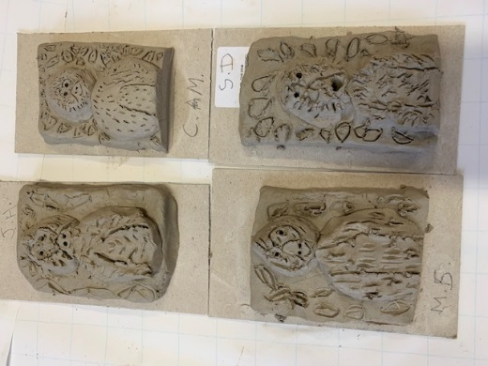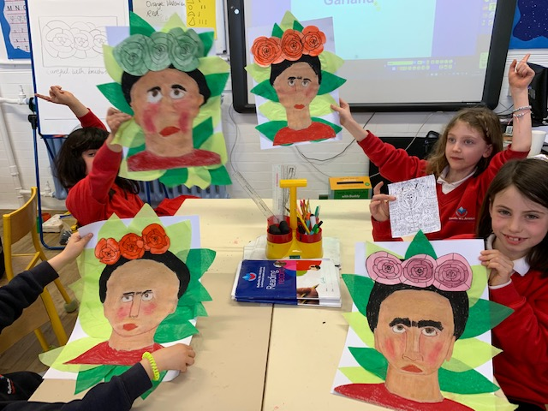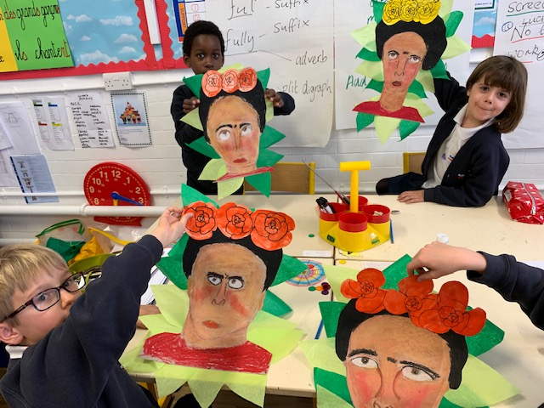**Year 3B Art 2018-19**

The finishing touch – a clay model of a monkey to go on her shoulder!

By blending oil pastels and careful use of water colours, we created distinctive and individual pieces of work

We created our own portraits based on the artwork of Frida Kahlo.