

**Year 3 Roman Day 2018-19**

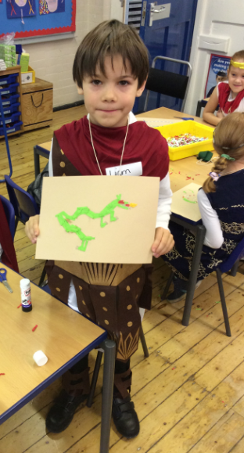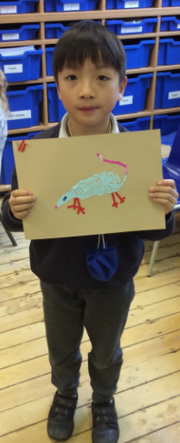

Year 3 spent a wonderful day together dressed up as Romans. We learned how to make mosaics and how to write our birthdays in Roman numerals.

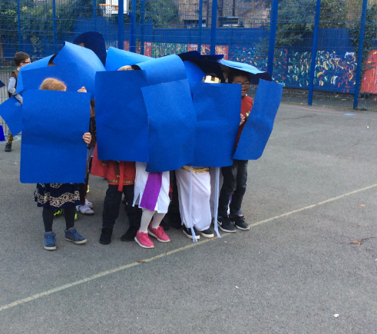

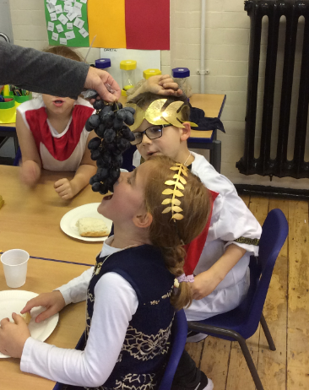

We had a Roman debate in the hall to discuss right and wrong.

We then went outside to practise our tortoise formation. We worked up an appetite for our big Roman feast at the end of the day!