

**Year 2’s visitor from the Florence Nightingale Museum 2018-19**

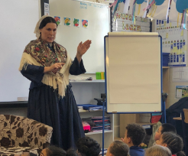

A member of the Florence Nightingale Museum came to visit us at school to do a workshop about this famous and celebrated nurse.

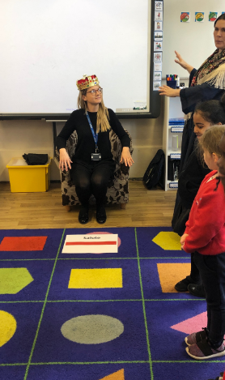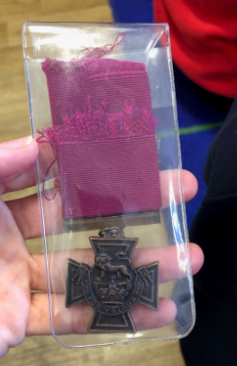

They also enjoyed role-play activities and explored why Florence went to the Crimea.

The children got to engage with a selection of historical artefacts.