

**Year 2 ICT 2018-19**

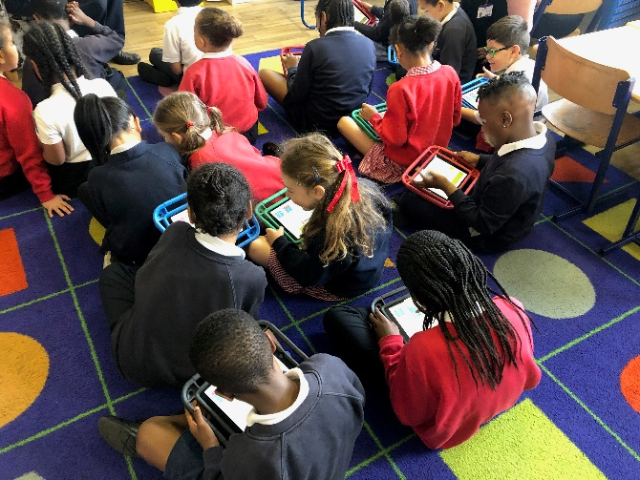

Year 2 learnt about coding using the Hopscotch App. Through this app they were able to create games!

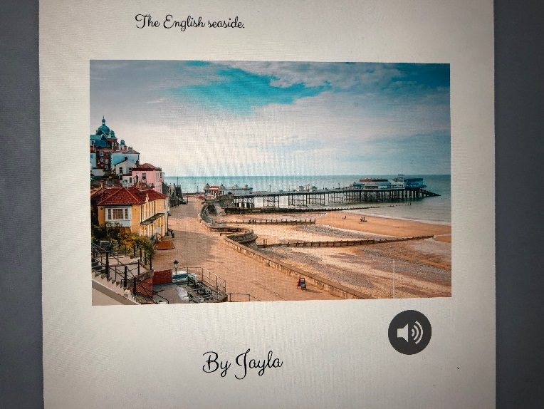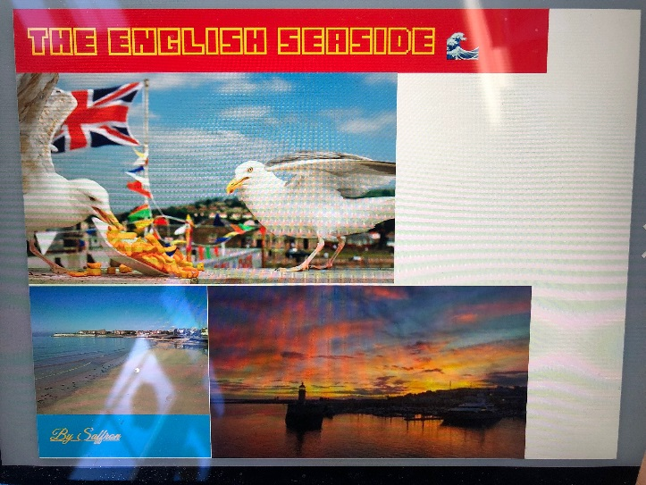

They then used safari search engine to search for images on the English seaside which is what we are learning about in topic. They were able to transfer these images to books that they created using the Book Creator app.

