

**Reception Mother’s Day 2018-19**

**1B Science Museum Trip 2018-19**

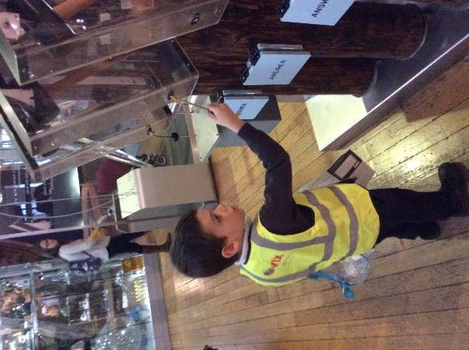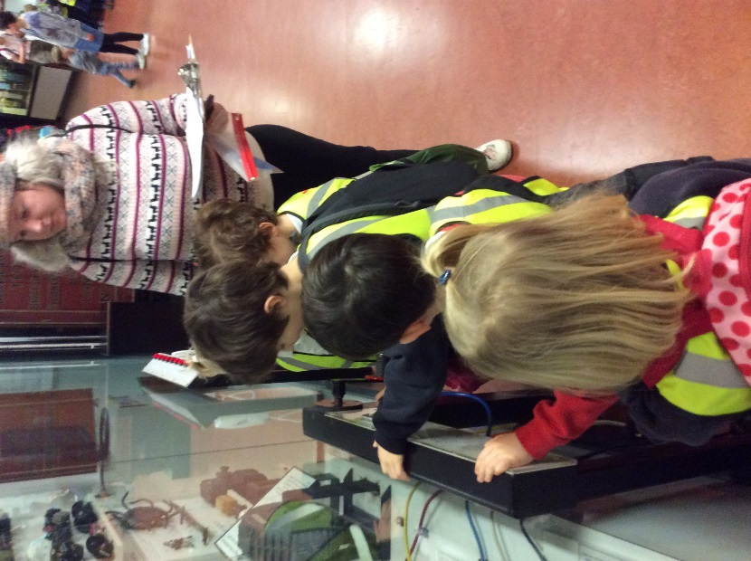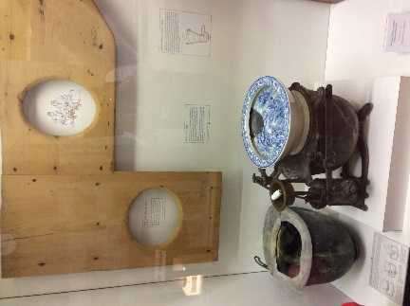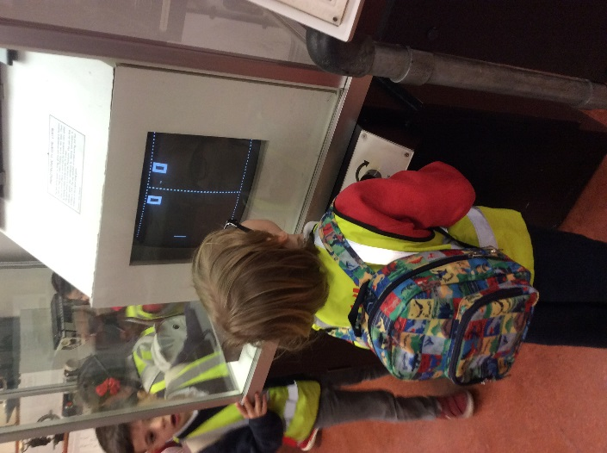

The children explored a gallery all about materials and were able to use their knowledge from their autumn term learning to distinguish between different types of materials.

The children enjoyed learning about how domestic life had changed, particularly the evolution of the toilet and games consoles!

We got the bus to the Science museum to explore galleries about changes to the home and materials.