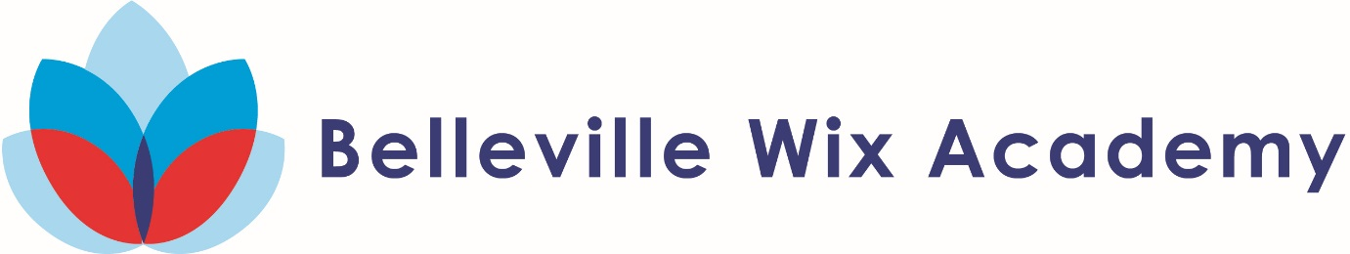

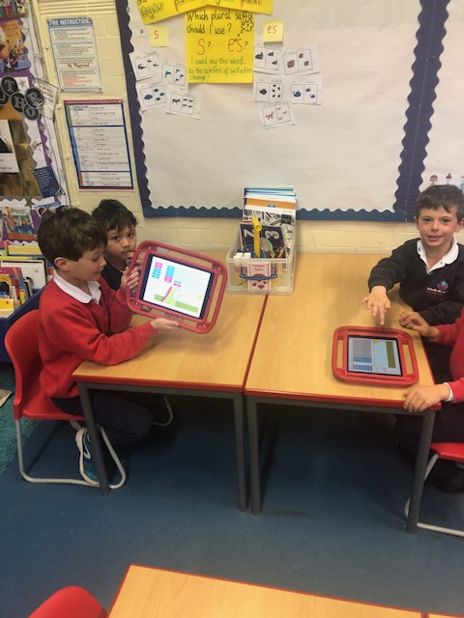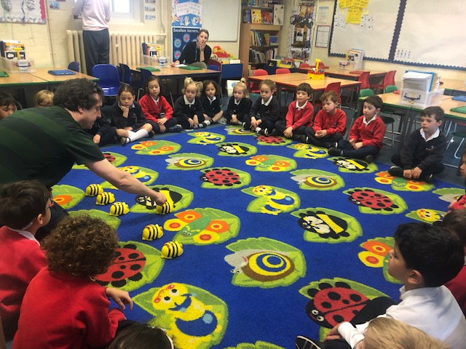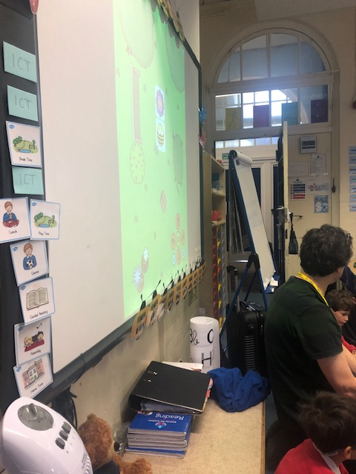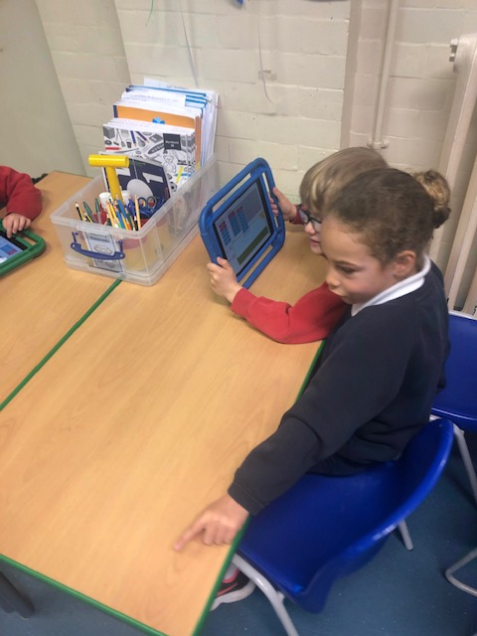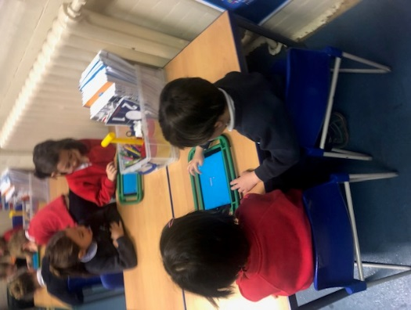**Year 1B ICT 2018-19**

The children then had a go at programming Beebots and then applying that learning to an iPad app. They are becoming excellent coders!

Year 1B were lucky to have Dave come and join them to discover some new iPad apps.

First of all 1B explored an iPad app to practise their handwriting and then had a go at some basic coding using a dinosaur app to link with our topic of the half term.