

**Reception Mother’s Day 2018-19**

**1AB Local Area Trip 2019-20**

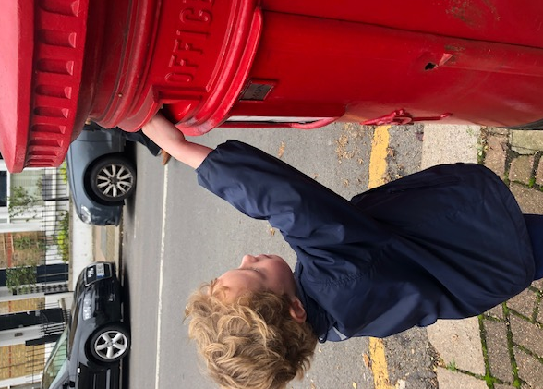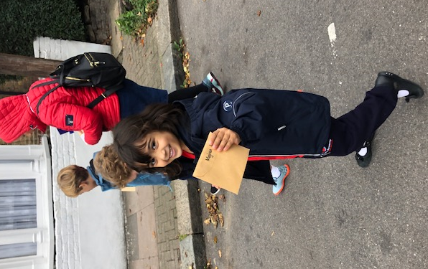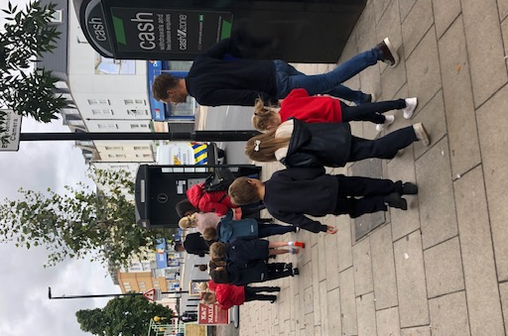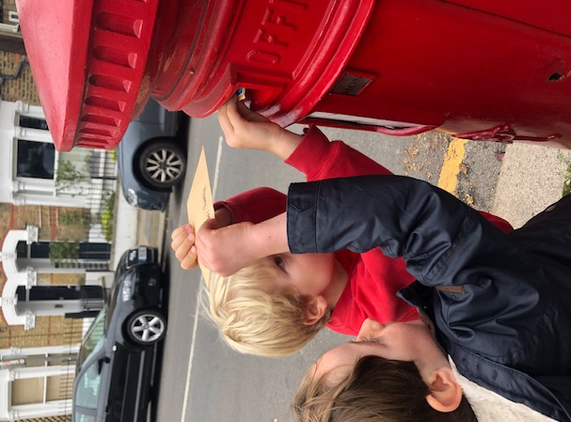

The children identified different housing types and local landmarks. They were then able to post themselves a letter they had written during their previous learning.

As part of our Geography topics we took a trip around our local area with the help of some Mums, Dads and Grandmas.

Finally, we stopped by the common to observe mansion flats and detached houses that you can see along the edge. We also had a game of stuck in the mud with Miss Baker!