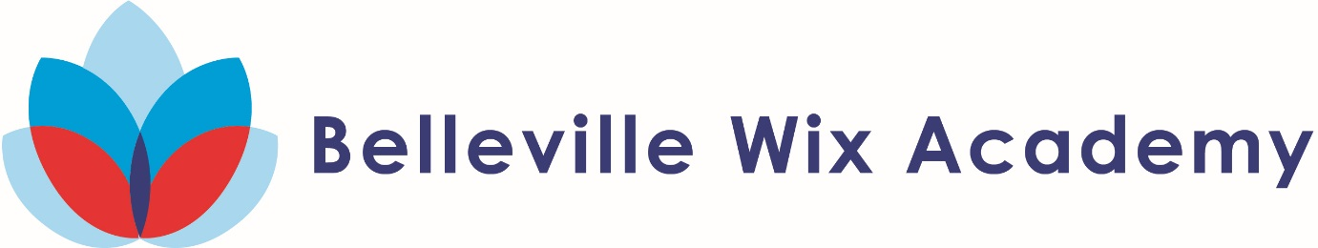

**Year 1 Trip to 1 2018-19**

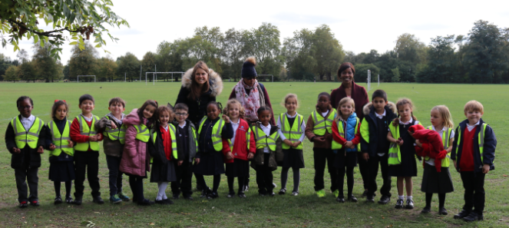

During the autumn term we had great fun exploring our local area. We posted letters in a post box, ticked off what we could see in the common and even collected conkers!

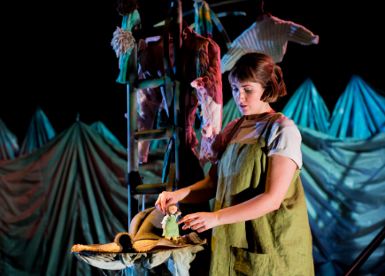

In December, we visited the Omnibus Theatre to see ‘The Selfish Giant’. We enjoyed seeing how they used puppets in the production.

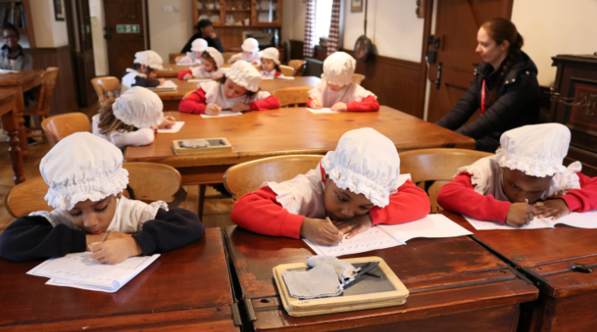

In January, Year 1 visited Holly Lodge and had experienced what it would be like to have lessons in a Victorian Classroom!

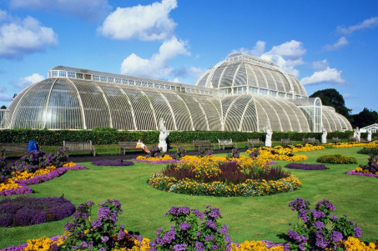

In March, we had a wonderful time visiting Kew Gardens and exploring the beautiful plants and wildlife.