

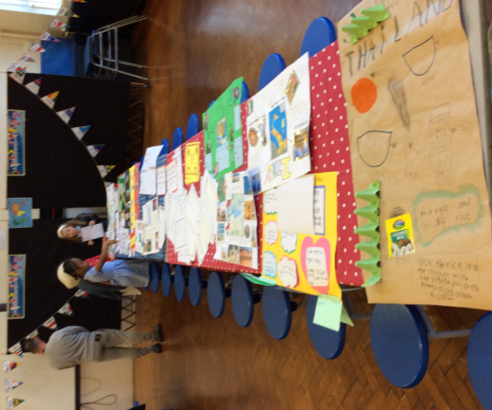**Year 1 International Morning 2018-19**

Year 1 had a wonderful morning celebrating internationalism. All the children made beautiful posters for the event on a country of their choice. I was blown away by the effort all the children made at home. Thank you to all parents who supported them in making such informative posters!

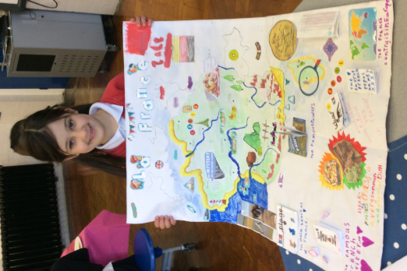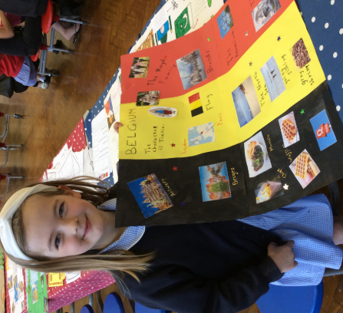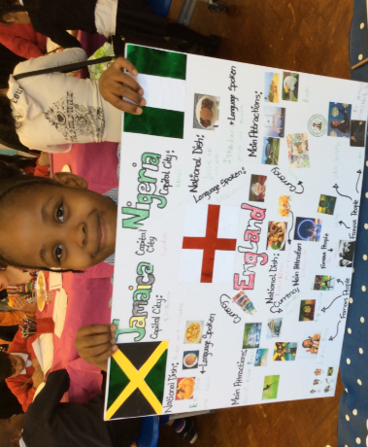

We also had delicious food from a variety of countries including; France, Pakistan, Lithuania, Cyprus, Spain, Jamaica, Iran and lots more!

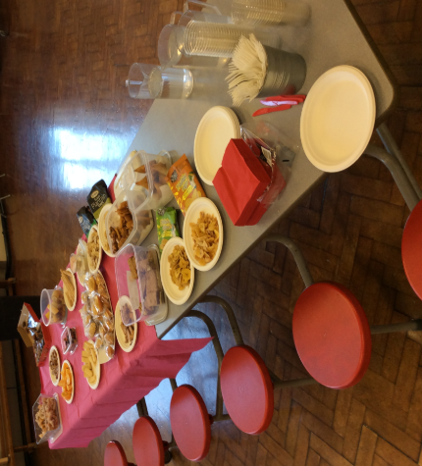

Thank you to all parents who were incredibly generous with the food they brought to share. There was a fantastic variety of what we had to eat and it all tasted amazing!