Year 1 ICT 2018-19

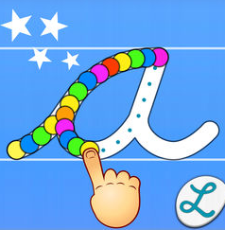
Working with the experts from CLC, Year 1 have been learning how to explore a variety of Apps to improve their computing skills.

To practise our handwriting and fine motor skills we used Cursive Writing Wizard.
We used Book Creator to create books on our favourite animal which was linked to our Science topic.
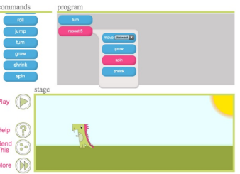

We practised our coding skills using Daisy the Dinosaur App. We learnt how to sequence commands to make her move, walk, jump, turn, shrink and grow.
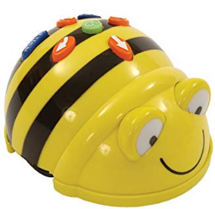
We also practised our coding skills on the Bee Bot App. We first used concrete Bee Bots and then used the App to code.

We made kaleidoscope shapes and patterns using the Kaleidoscope App.

