

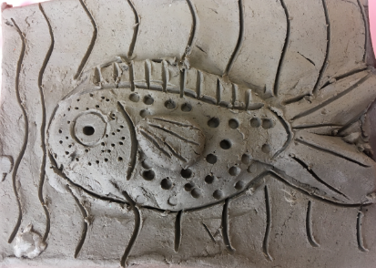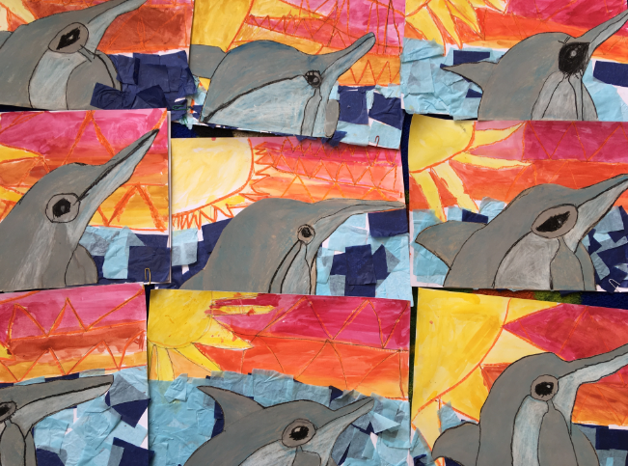**Year 1 Art 2018-19**

Next also created fish out of clay. We used our fingers and tools to create the detailed scales and patterns on our fish. I am sure you will agree that the results are fantastic.

We created these beautiful dolphins jumping out of the water using a variety of materials and techniques to create them, including pencil, pastel, watercolour and tissue paper.

Everyone worked very hard and really enjoyed the day!

Excellent learning Year 1!

Year 1 had a fantastic time learning how to create works of art based on our Topic in Science, ‘Animals.’