Stay Active Whilst at Home!
It can be tricky to stay fit, healthy and active whilst we are all at home. To make it easier, check out these websites that have some great ideas to help you stay active.
The Daily Mile at Home

Marathon Kids Lockdown Activity Hub

Youth Sport Trust PE Home Learning

Accessible indoor activities

FREE Gymnastics and Zumba classes
Coaches from Enable Leisure and Culture will be leading virtual kids’ gymnastics and Zumba classes. They are completely free and available to anyone. They are all live streamed through Zoom. Please see the schedules below.
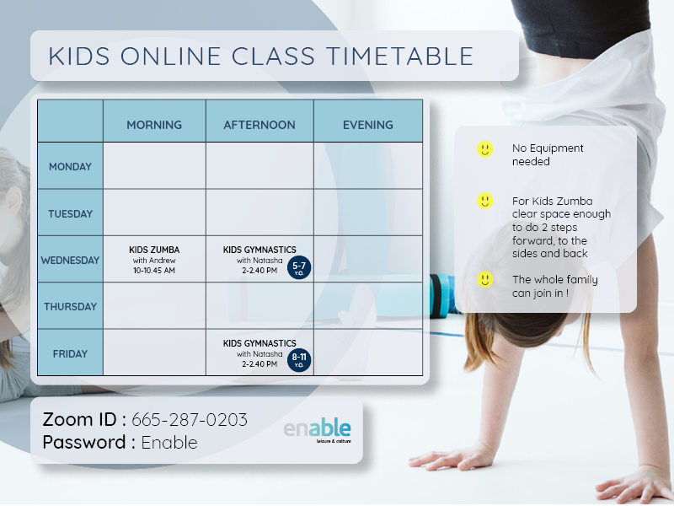
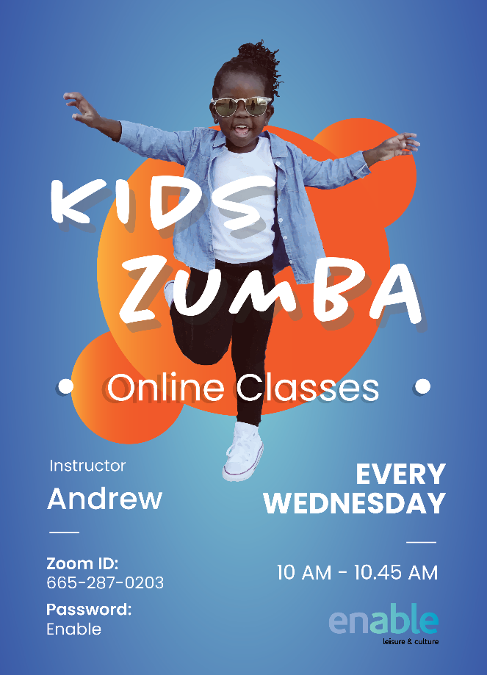
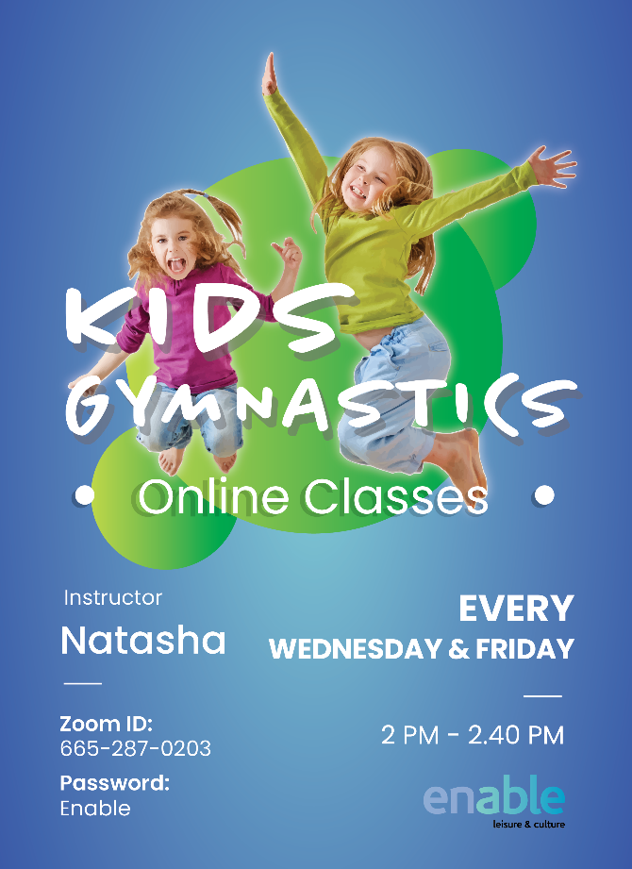

30 Day Kids Sports Coordination Course
Emma Wells Tennis are offering a 30 Day Zoom Sports Coordination Course starting on Monday 4th May. Please see details below.
To book on click here https://forms.gle/qaRNW2yySgf2CUAQ7
