Spring Term Artist - William Turner
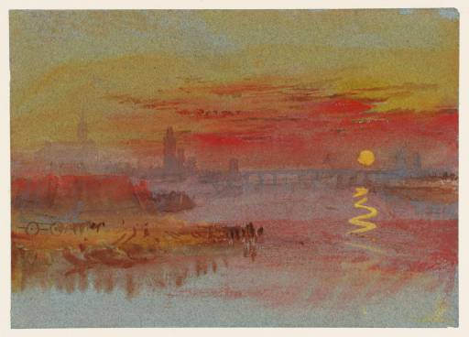
“I know of no genius but the genius of hard work.” JMW Turner.
Pupils in KS2 were inspired by the XVIII century British master of illusion, William Turner. To master their watercolour technique pupils used different washes and gentle brushstrokes, with a selection of paintbrushes, to paint the artist’s favourite subject, a sunset.
Technique: watercolour.
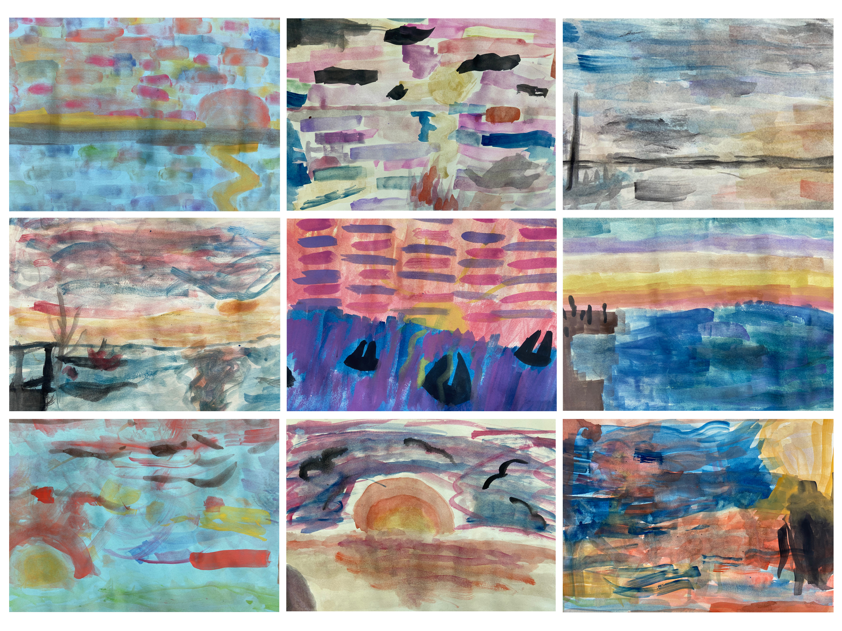
Key words: washes, depth, horizon, warm colours, cold colours, illusion, distance.

