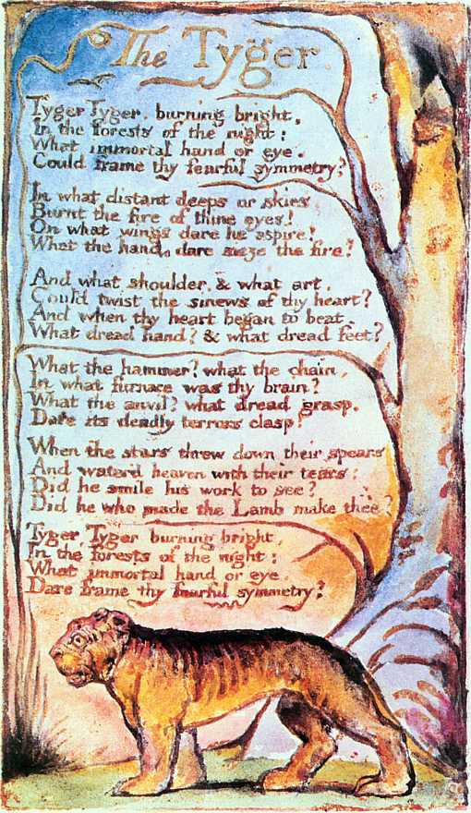
Spring Term Art- inspired by William Blake
The Tyger
Pupils in KS2 were inspired by William Blake’s poetry. After a discussion about Tyger attributes, pupils created their own vision of a fierce animal and its surroundings, over two layers.
Techniques: watercolour, black gel pens.
Key words: symmetry, warm colours, fierce, fire like pattern, symbolic, poetry, illuminated books.

