

**Spring Progress and Attendance Awards 2018-19**

Every term, at Belleville Wix Academy, we celebrate the wonderful progress achieved by our students during the previous term. Awards are received based on the children’s progress in Reading, Writing and Mathematics.

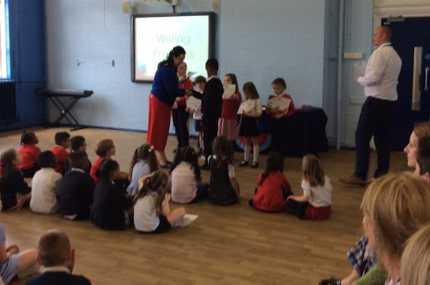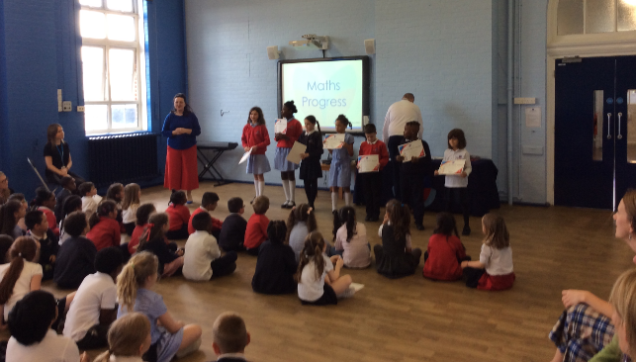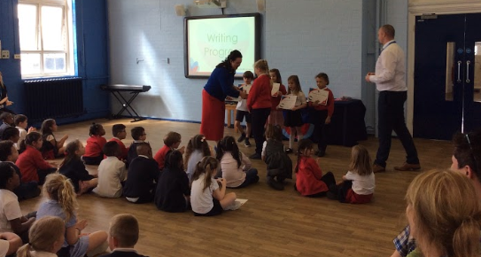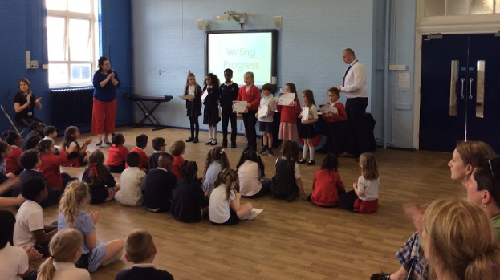

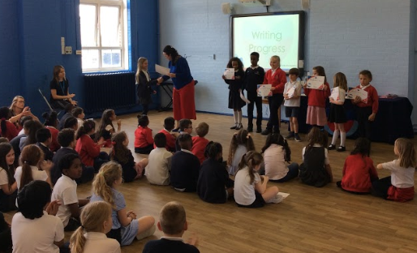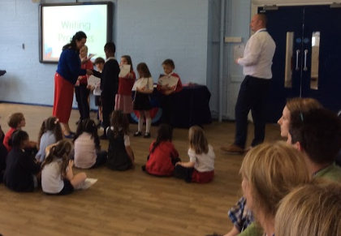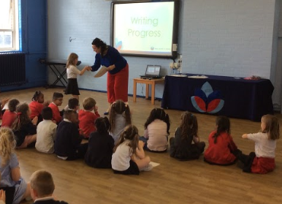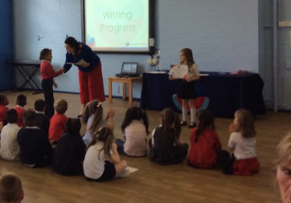

At Belleville Wix Academy, attendance is incredibly important. Each term, we celebrate the children who have received 100% attendance.