

Dear parents/carers,

Q1E is looking at some different ways of enhancing our home learning through the use of technology. I have been given the opportunity to explore an online learning platform with our class.

Please be aware that this may not necessarily continue beyond a few weeks.

Seesaw is a secure online system that enables learning to be shared between school and home through pictures, videos, voice messages and more. We would love your support in exploring this new platform.

Please see the instructions below on how to set up your child’s Seesaw account, and the linked FAQs for additional support.

Many thanks,

Miss Stuart

How to log on to Seesaw:

Tutorial video: https://www.youtube.com/watch?v=uIGnw6OW0WA&feature=youtu.be

Seesaw can be accessed through the website
https://app.seesaw.me/#/login
or through the Seesaw CLASS app (available for Apple and Android):
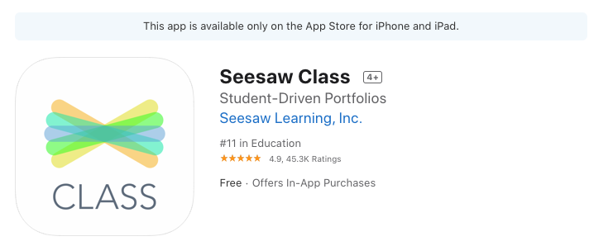

Hi,
Please join our class today!
If you’re using Seesaw for the first time:
- Go to app.seesaw.me
- Choose "I’m a Student"
- Type in the code: JYMO HBVO. This code expires on Apr 29, 2020.
- Finish creating your account using your school Google account or email address and your child’s name. Please note that if you have siblings, you will need a separate email address for each child.

If you’ve used Seesaw before and have an account:
- Go to app.seesaw.me
- Choose "I’m a Student"
- Sign in using your school Google account or email address
- Click on your profile icon on the top left
- Click on the +Join Class button
- Type in the code: JYMO HBVO. This code expires on Apr 29, 2020.

