

**Reception Mother’s Day 2018-19**

**School Council Voting Day 2019**

In September, Belleville Wix Academy held our School Council Elections!

Each class went to our Polling Station where they were given voting cards.

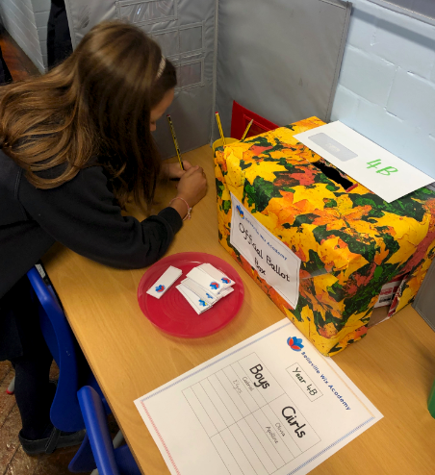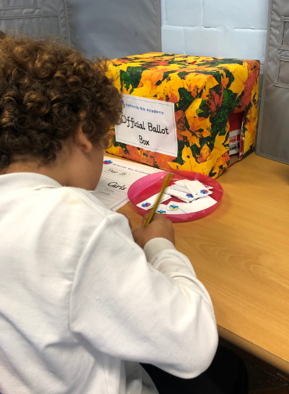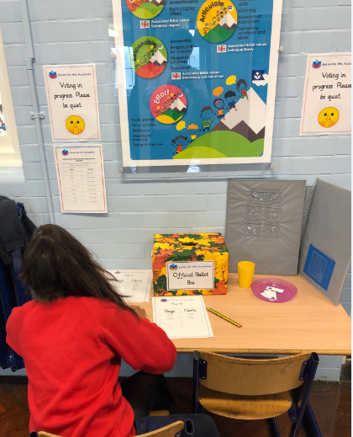

Each child made their vote and placed these into a ballot box. They really enjoyed this process and everyone took it very seriously.

“When I was voting it was very fun because I got to vote for someone who I thought would be a responsible member of the School Council. It was exciting putting my vote into the Ballot Box!” - AS (Year 2)