

**Reception Mother’s Day 2018-19**

**School Council’s First Meeting**

On Thursday 10th October, School Council had their first breakfast meeting.

We discussed all our ideas and upcoming charity events over a croissant.

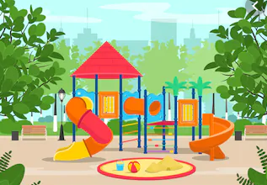

Our first charity event is to raise money for Children in Need which is on Wednesday 13th November. We hope you support us in our first school council event!

Each child came with fantastic ways to improve our school, including ways to make our playground better and how to raise money.