Dear Parents and Carers,
Re: The wider opening of BWA to pupils in Reception, Year 1 & 6
On Thursday 28th May, the Prime Minister announced that the 5 tests were being met and therefore schools could open to more pupils. I hope this letter sets out most of the details you will need to make an informed choice about whether you feel it is safe for your child to return to school. You may also be interested in reading the SAGE report that has been published, showing the risk assessment of several models for the wider opening of schools. It is attached on this link. https://assets.publishing.service.gov.uk/government/uploads/system/uploads/attachment_data/file/886994/s0257-sage-sub-group-modelling-behavioural-science-relaxing-school-closures-sage30.pdf
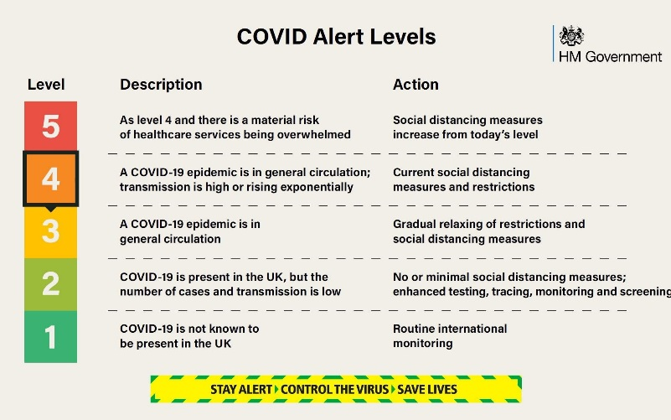
At the time of writing to you, the risk to the UK is high and we are at stage 4 of the outbreak, as set out in this diagram.

As a school, we have tried to identify the potential risks pupils and adults may be exposed to whilst at school and establish the steps we could take to minimise these. The information, set out below, is a summary of the changes we are making in school. These arrangements will be fluid so we can respond to the needs of the pupils and adults.
It is important to remember that as a school community we all play a big part in reducing the risk of spreading the virus. The decisions we make outside of school will have a significant impact on those we are in contact with at school. Therefore, I am asking you, and staff, to consider how the choices you make outside of school affect the chances of spreading the virus in our school. I do hope that we can all work together to minimise the spread of the virus, to keep each other safe.
Once you have read this information, we would be very grateful if you could inform us of your decision to send your child back to BWA, by 12pm on Thursday 4th June, so we can finalise arrangements. https://forms.gle/Wcrps7CANFv6UR8c7
Yours sincerely,

Seana Henry
Headteacher
Summary of the changes being made at BWA
Social distancing | The government say they know that, unlike older children and adults, primary age children cannot be expected to remain 2 metres apart from each other, and staff. In deciding to bring more children back to schools, the government tell us they are taking this into account and are asking us to work through the hierarchy of measures set below:  - avoiding contact with anyone with symptoms  - frequent hand cleaning and good respiratory hygiene practices  - regular cleaning of settings  - minimising contact and mixing  It is still important to reduce contact between people as much as possible.  Pupils and staff should only mix in a small, consistent group and that small group should stay away from other people and groups, where possible.  Pupils will sit at desks and be spaced out as far apart as possible.  Dependent on the number of pupils returning, we cannot ensure that pupils will be sat at tables 2 metres away from each other.  We will have a staggered start and end of day. The times will be shared with you later this week.
COVID symptoms | Please do not enter the school site, or send your child to school, if either of you have symptoms of the virus.  We know that carriers of the virus may not show any signs of the virus and this is a concern that I am sure we all share.  Staff will have access to a thermometer to take pupils temperatures, as they feel is necessary.  Pupils who show signs of symptoms will be asked to go home and we ask that parents collect their child without delay, in this circumstance.
Staff Absence | Staff absence in a hub, may result in the pupils in the hub not being able to attend school.  We will endeavour to inform you as soon as this is the case. Please be aware that you may be informed on the morning that the hub is unable to attend school on the same day. I sincerely apologise for this as I know it is not ideal for you. Please be assured it is to keep your child as safe as possible.
Covid 19 test/ self-isolation | Pupils or teachers with symptoms will be able to get tested.  We will advise parents and carers in a hub affected by this, at the time.  Where a test result is positive, guidance states: “the rest of their class or group within their childcare or education setting should be sent home and advised to self-isolate for 14 days”.  “The other household members of that wider class or group do not need to self-isolate unless the child, young person or staff member they live with in that group subsequently develops symptoms.”  If other cases are detected, Public Health England’s local health protection teams will conduct a “rapid investigation” with the potential for the whole class or year group asked to self-isolate.
Hygiene | Please ensure that your child’s school clothes are washed after each day at school, in line with government guidance.  Throughout the day pupils will be asked to wash their hands with soap and water.  We will remind the children regularly about coughs and sneezes, using the phrase - Catch it, bin it, kill it.
Class size & teacher | Pupils will be split into hubs of no more than 15. They will not all be taught by their class teacher.  Class teachers will assign pupils to the hubs based on their knowledge of the pupils in their class. Twins will be allocated to the same hub.  Pupils in the hubs will not mix with other hubs – as explained above.  Where possible two adults (a teacher and TA) will be assigned to a hub.  Teaching assistants can be allocated to lead a group, working under the direction of a teacher, if there are shortages.
Classroom | Hubs have been assigned rooms across the BWA site. Many pupils will not be in their usual classroom.  The rooms have been stripped back to tables and chairs to ensure we can social distance as much as possible.  Pupils will not share resources outside of their hub.
Travel to school | We ask that you make every effort to:  - avoid public transport  - walk to school  - avoid bringing scooters or bikes onto the site, for reasons of contamination and storage space
Drop off and collection | We ask that only one adult accompanies the child (ren).  All BWA-registered children will enter and exit the site, at the times assigned to their hub, via the 1902 gate.  Parents are asked to queue on Wix’s Lane towards the Common, with 2m distances between each family group.  Residents of Wix’s Lane will be been informed of this arrangement, but we ask that you are of course mindful of allowing access to residents and pedestrians whilst you queue.
Lateness | We ask that you endeavour to ensure that you drop your child off and collect your child at the precise times to be given.  Arriving late increases the risk of the groups mixing, which we want to avoid.  Any child who arrives outside their allotted time will need to wait at a distance with you, until staff are available to take them to their hub.  Equally, at the end of the day, the impact of a child who is collected after the allotted time will be particularly compromising for the member of staff charged with their care.
After drop off | We kindle request that parents to not congregate outside the school.  If you wish to catch up with one another, please ensure that this happens with the appropriate social distance between you and away from the school site.  The window for children entering and exiting the site of necessarily large and their safe and calm coming and going must be our shared focus at these times.
Movement around the school site | There will be  - staggered entry, exit and break times  - pupils will eat their lunch in the hub classroom  - signs have been displayed to remind pupils to stay 2m apart when moving around the school  - pupils will be accompanied throughout the day by the adult(s) in their hub  Parents will not be allowed onsite unless invited by the headteacher.
Water fountains | Please provide your child with a bottle of water each day.  All water fountains have been disabled to avoid contamination.
School Dinners | A packed lunch option will be available. See Google form to order a packed lunch from school.  These will be delivered to the classroom and pupils will eat in their hub classroom.
Curriculum | It will not be practical to adopt the traditional approach to teaching that we are used to.  We will also continue with the home learning currently set up.
Bilingual Stream | Pupils in the bilingual stream will be taught in their registration groups.  It will not be possible to continue the traditional approach to teaching the classes in this stream, as explained in my joint letter with M. Bonnefoy to you last week. We are working with Ecole de Wix to find ways of ensuring some bilingual provision and exposure to your child’s French teacher each week, but both schools are firmly in agreement that the safety of the children and staff must come above the spirit and execution of our 2-way immersion provision at this time.
Shared Site | BWA is a unique school as we share a site and stream with the Lycee. In order to ensure we are all safe and able to ensure our own institution’s safety protocols at this time, precise areas of the building have been allocated for each school.  BWA  - Based on the ground and first floor  - Pupils and staff to access the building using the back stairwells and main reception area.  - Have dedicated areas for outside provision  - Pupils enter the site via the 1902 gate  Ecole de Wix  - Based on the second and third floors  - Pupils and staff to access the building using the main, front stairwell  - Have dedicated areas for outside provision  - Pupils enter the site via the car park gate  - Will not be onsite on a Wednesday
PPE | The guidance states that “the majority of staff in education settings will not require PPE beyond what they would normally need for their work, even if they are not always able to maintain a distance of 2 metres from others”.  The occasions where PPE is needed are for children whose care “routinely already involved the use of PPE due to intimate care needs” or if a youngster becomes unwell with coronavirus symptoms and needs “direct care until they can return home”.
5 day a week provision | We are offering a 5 day provision.  We will operate a staggered start and end to the day.  It will be a shorter day onsite. Specific timings will be shared with the hubs once these are confirmed.
Phased wider opening proposal Monday 15th June | - Yr 6 - Monday 8th June  - Yr 1 - Wednesday 10th June  - Reception – Monday 15th June

