

**Reception Mother’s Day 2018-19**

**Reception School Nurse Visit 2018-19**

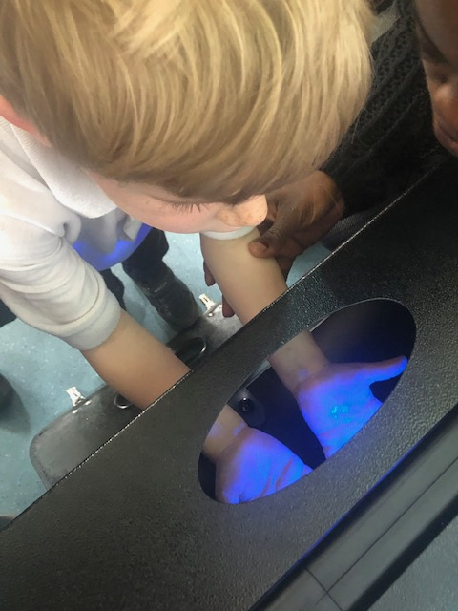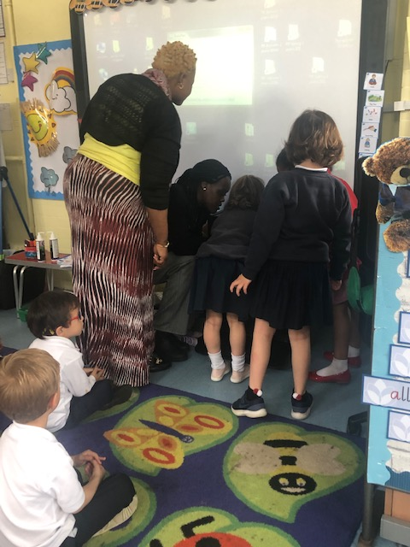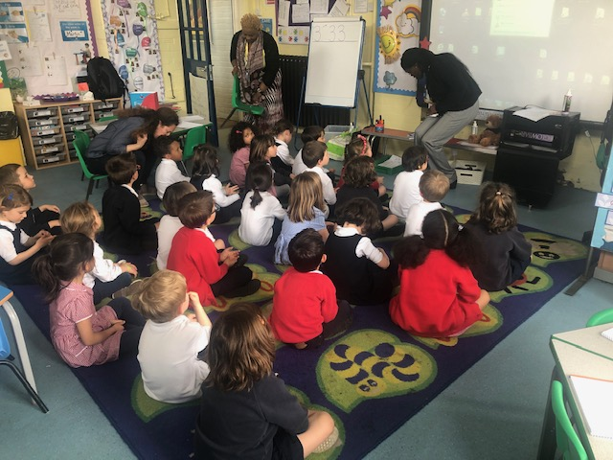

They brought a germ detector with them so that we could see all the germs on our hands! The children were very shocked at how dirty our hands were!

After washing their hands the children were very proud to see that the germs had gone. Which reminded them that it is very important to keep washing their hands!

We had some very special visitors in Reception! The school nurses came in to make sure we were washing our hands correctly.