

**Reception Mother’s Day 2018-19**

**Reception Mother’s Day 2018-19**

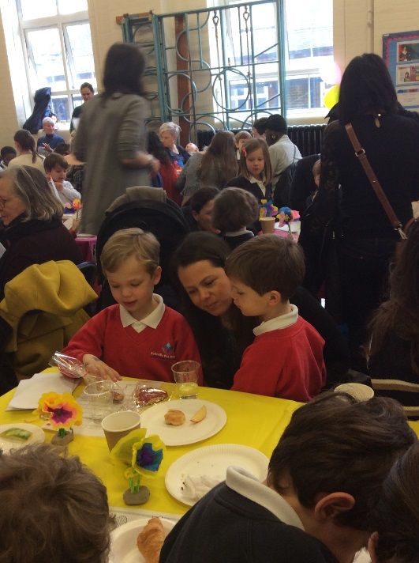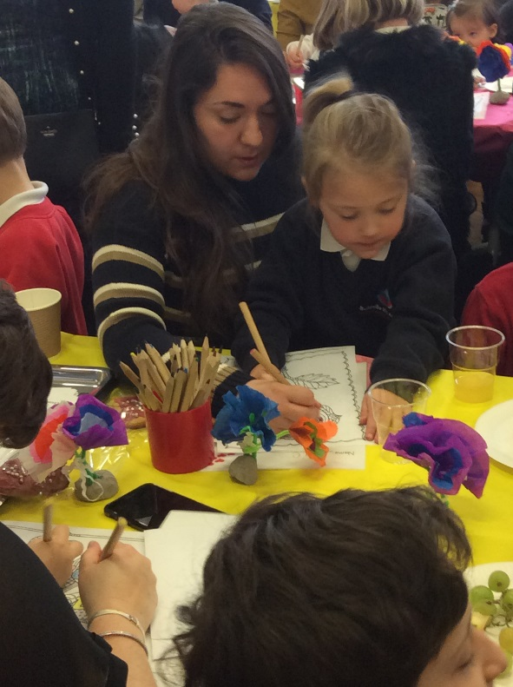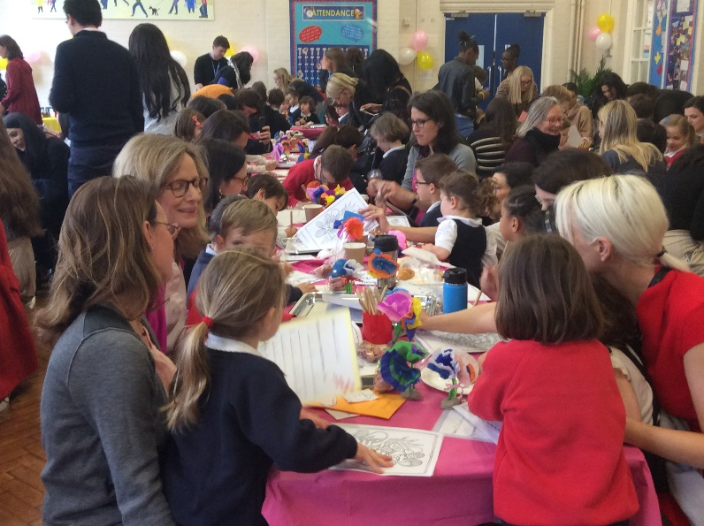

The children enjoyed sharing the poems they had written for their mummies and doing some mindfulness colouring.

The children made flowers, biscuits and cards for their mummies to take home. We even sang 2 special Mother’s Day songs!

We invited all of the mother figures into school to enjoy a special Mother’s Day breakfast. It was very busy and very exciting!