

**Reception Mother’s Day 2018-19**

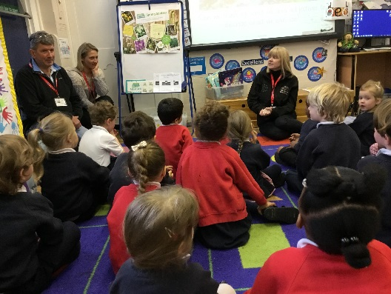**Gardening in Reception 2018-19**

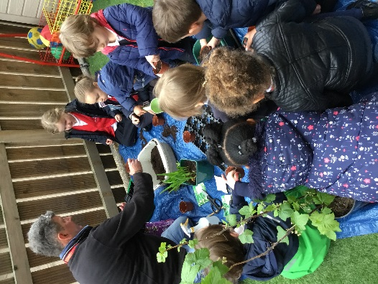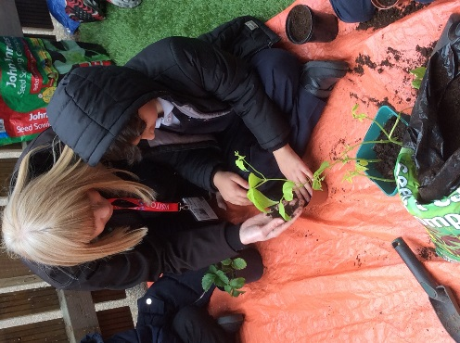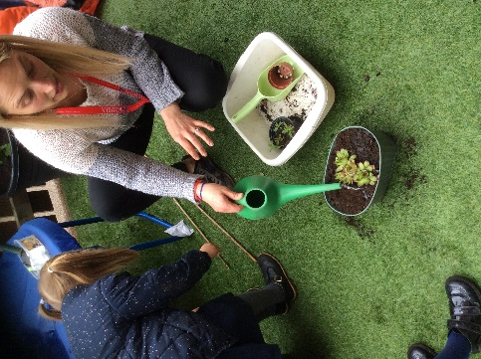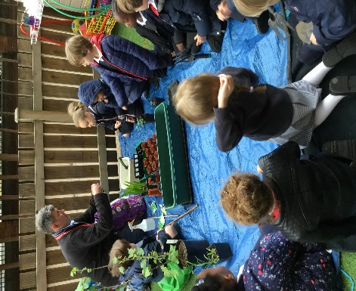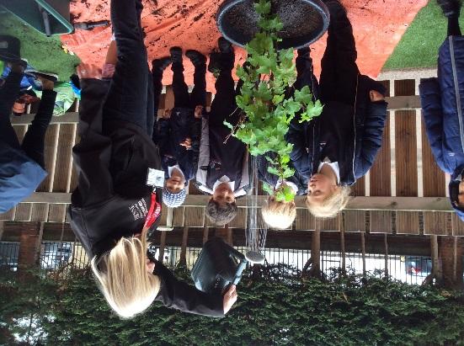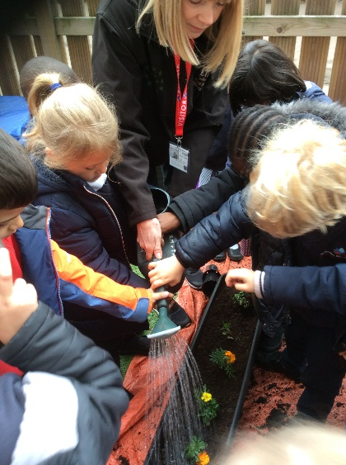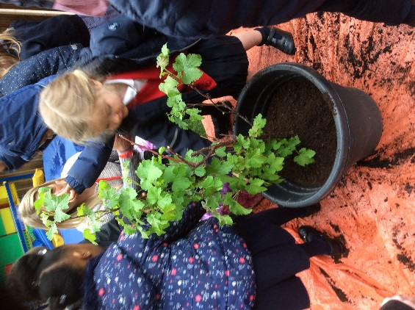

Lorraine taught the class some new words, testa is the coating around the seed to protect it. The class saw the roots of the plants and discussed what they were used for.

We planted herbs, peas, beans and even a strawberry plant! We’re very excited to see how much they will grow.

In Reception we have become very keen gardeners thanks to some very special helpers.