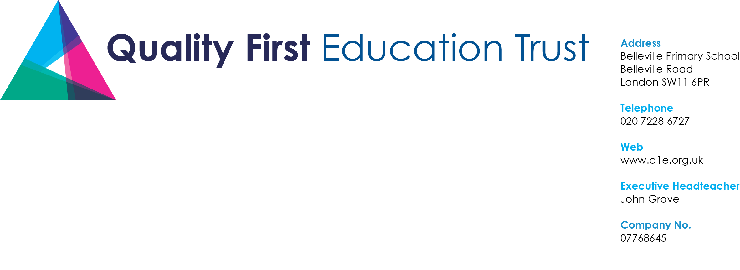

22nd May 2020

Dear Parents /Carers,

I hope you and your families are well and remain well. At Quality First Education our first priority is that your children, your families and our staff are safe. As we await a government announcement confirming when schools can start opening more widely, we want to keep you informed of the decisions we are making. The latest advice is that the government will not make a decision about any possible increase in school opening until 28th May.

Last night, all our headteachers met with the trustees of the Quality First Education Trust to discuss plans for wider opening and how we can improve safety and minimise risks for children and staff.

We have decided to increase the offer to key workers and other particular children by opening an additional provision at the Alton. We will, therefore, have a provision in Bromley, Roehampton and Clapham. The number of children attending our schools at Belleville Meteor and Churchfields has increased over recent weeks and will continue over half term next week. If you want to use this facility and believe you are entitled to do so under the government schemes, please contact the appropriate headteacher.

It was also decided that we will not open our schools “more widely” until at least 8th June. Any opening from this date will depend upon government advice and our headteachers and trustees being confident that we have addressed all relevant guidance to keep your children and the staff safe.

We will continue our home learning offer based upon the logic of ‘we share, we talk, you share’. This will continue throughout the summer term. We will not set any new home learning for the half term holiday week. If you do want to, you can of course look back at the previous learning and activities and these will remain available. Teachers continue to update videos, stories, assemblies and things to do on our website and we encourage you to explore these. There is no expectation for you or your child to do or share additional work over the half term.

To supplement the home learning strategy, we will be making the maths workbooks and accompanying textbook materials available for you to collect so these can be used at home. Your school will inform you of the time and arrangements for you to collect your child’s maths books; this is being planned to start from Monday 8th June.

In the meantime, we will continue to plan for and prepare staff and facilities for the wider opening when this happens. We will explain the details of the organisation, staffing, revised times, revised expectations, etc at school level once we have specific dates for wider opening.

I will keep you up to date with the trust policies and procedures and headteachers will contact you about issues specific to your schools.

I wish you and your families a very happy and safe half term. Thank you all for your continuing support.

Yours,

John Grove (Executive Head)

