Executive Headteacher:
John Grove
Headteacher:
Séana Henry

Wix's Lane, Clapham Common North Side, London SW4 OAJ
Tel: 020 7228 3055 Fax: 020 7978 4942 Email: admin@wix.wandsworth.sch.uk

Thursday 22nd April 2020

Dear Parents and Carers,

I hope you and your families are well.

We know that you are busy completing the great home learning activities. Many of you have posted some of your wonderful work on Seesaw and we are really enjoying see what you have posted. Thank you.

Access to reading materials can be a little tricky for some of you and we wanted to share a new resource we have for you to access. This is an additional reading resource to Bug Club to allow your child to access an even wider range of books whilst home learning.

Starting next week, the Early Years Foundation Stage online home learning plans will include an additional reading resource from the website Oxford Owls:
https://www.oxfordowl.co.uk/

To access this resource you will require a class login and password which is listed below for each EYFS class:

Nursery: Username: Miss Gray Password: bellevillewix
RB: Username: Miss Chapman RB Password: bellevillewix
RM: Username: Miss Mohammed Password: bellevillewix
RO: Username: Miss Ogilvie Password: bellevillewix

When logging in please ensure you select the option ‘my class login’ this is the pink icon pictured below.
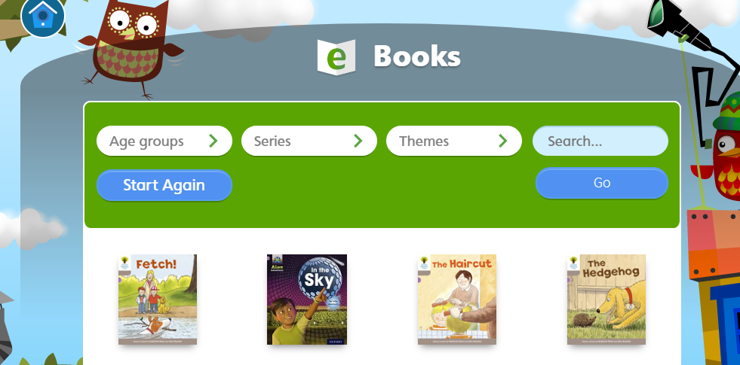
You will then have access to many ebooks and be able to search for the books listed on this week’s plan.

Please contact admin@wix.wandsworth.sch.uk if you have any difficulties accessing this.

Happy reading, stay safe and best wishes.

Miss Fisher
AHT for EYFS

