

**Reception Mother’s Day 2018-19**

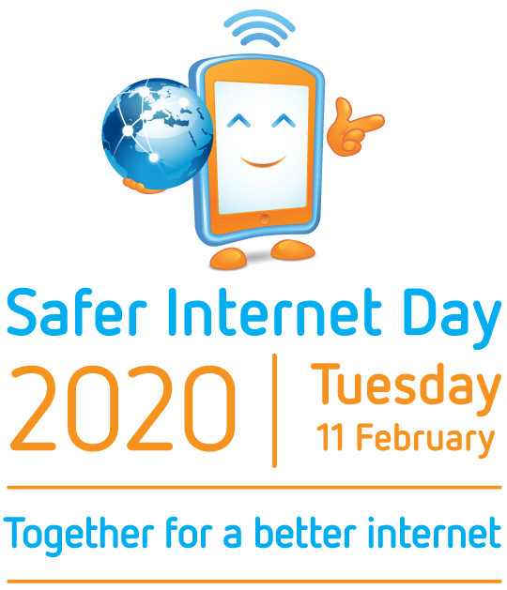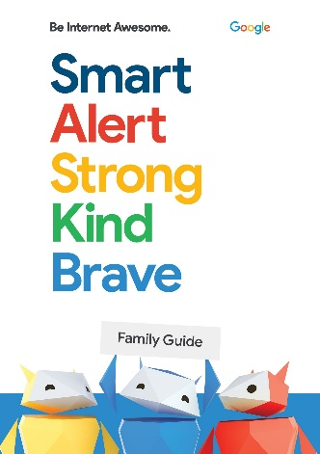**Online Safety Week 2020**

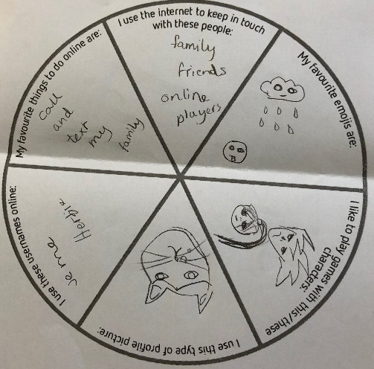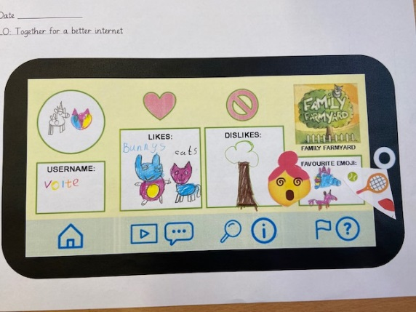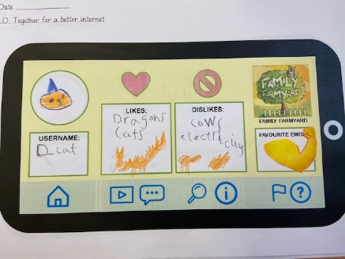

KS2 created their own online identities and tried to keep them safe from their friends.

KS1 read a story and created an online identity for the favourite character.

It is important to stay safe online. To mark National Online Safety Day we took part in additional events to recap on how to stay safe online. We read stories, created online identities and played fun games to learn the Do’s and Don’ts of using the internet. It was very interesting discussing how the internet could be a safer platform.