

**Reception Mother’s Day 2018-19**

**Puppet Show trip 2018-19**

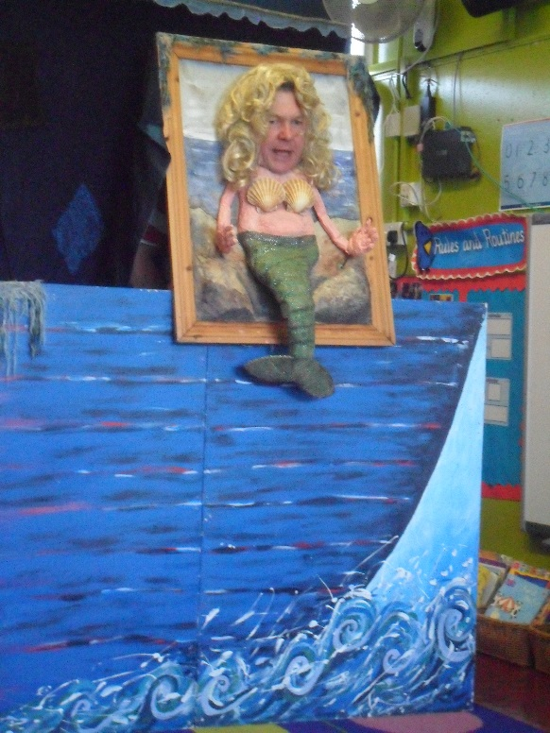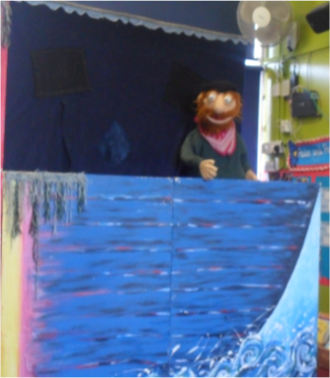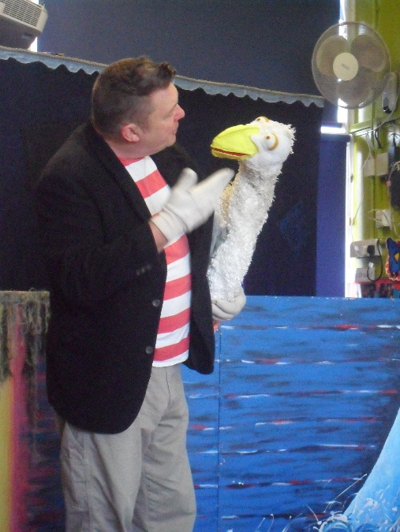

We also stayed to play with the children from Belleville Nursery and made some new friends.

The show was about creatures which live in and around the sea. The children thought it was very funny and we even met a ‘real-life’ mermaid!

Nursery were invited to see Squashbox Theatre’s, “The Sea Show,” at Belleville Nursery on Webbs Road.