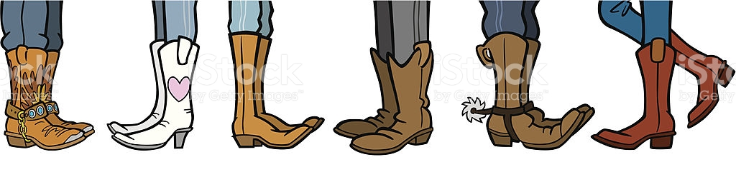

Dear Parents and Carers

BWA staff have created a little dance challenge fun for all the family at home. Learn the moves, turn the music up, give it a go and send in your video for our BWA Dance Video!

1. See Miss Ogilvie model the dance in this video
- https://vimeo.com/user12106273/review/418837158/f98eec37db​

2. Practice your dance using these videos for the music
Music: Cadillac Ranch by Nitty Gritty Dirt Band

See the band perform the song here
- https://www.youtube.com/watch?v=mRpahNzNNf8

What is a Cadillac? Look at these videos
- https://www.youtube.com/watch?v=ax1zQZhvVOs

- https://www.youtube.com/watch?v=sG54tahGUXY

3. Practice your dance – we hope the whole family will get involved and have a little fun together. Get creative – dress up, add props etc.

4. Video your performance.

5. Send us a video of your performance to BWAfun@wix.wandsworth.sch.uk by 30th May. We will create a magical video for everyone to enjoy the great fun we had dancing to the Cadillac Ranch.

We cannot wait to see your creative talents truly shine.

Just have fun!

