Child’s name Class
SCHOOL UNIFORM ORDER FORM

Item | Price | Size | Colour | Qty | Total
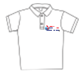 Short sleeve polo top | £7.50 |  | N/A
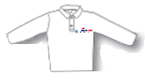 Long sleeve polo top | £8.50 |  | N/A
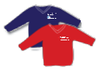 Sweatshirt | £8.50
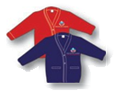 Cardigan | £8.50
P.E. T-Shirt | £5.00
P.E. Shorts | £6.00 |  | N/A
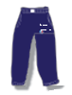 Joggers | £8.00 |  | N/A
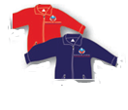 Showerproof jacket | £16.50
P.E. Bag | £5.00 |  | N/A
Book Bag | £8.50 |  | N/A
Rucksack | £12.00 |  | N/A
Total
Long sleeve polo and P.E T-Shirts
3/4 – 22/24
5/6 – 26
7/8 – 28
9/11 – 30
12/13 - 32
14/15 - 34

Joggers

3/4 – 24
5/6 – 26
6/7 – 28
7/8 – 30
9/10 – 32
11/12 - 34
All other items of clothing
3/4 – 22/24
5/6 – 26
7/8 – 28
9/10 – 30
11/12 – 32
13/14 - 34

P.E. Shorts

2/4 – 14/16
5/7 – 18/20
8/10 – 22/24
11/13 – 26/28

