

**Weekly Newsletter 22nd May 2020**

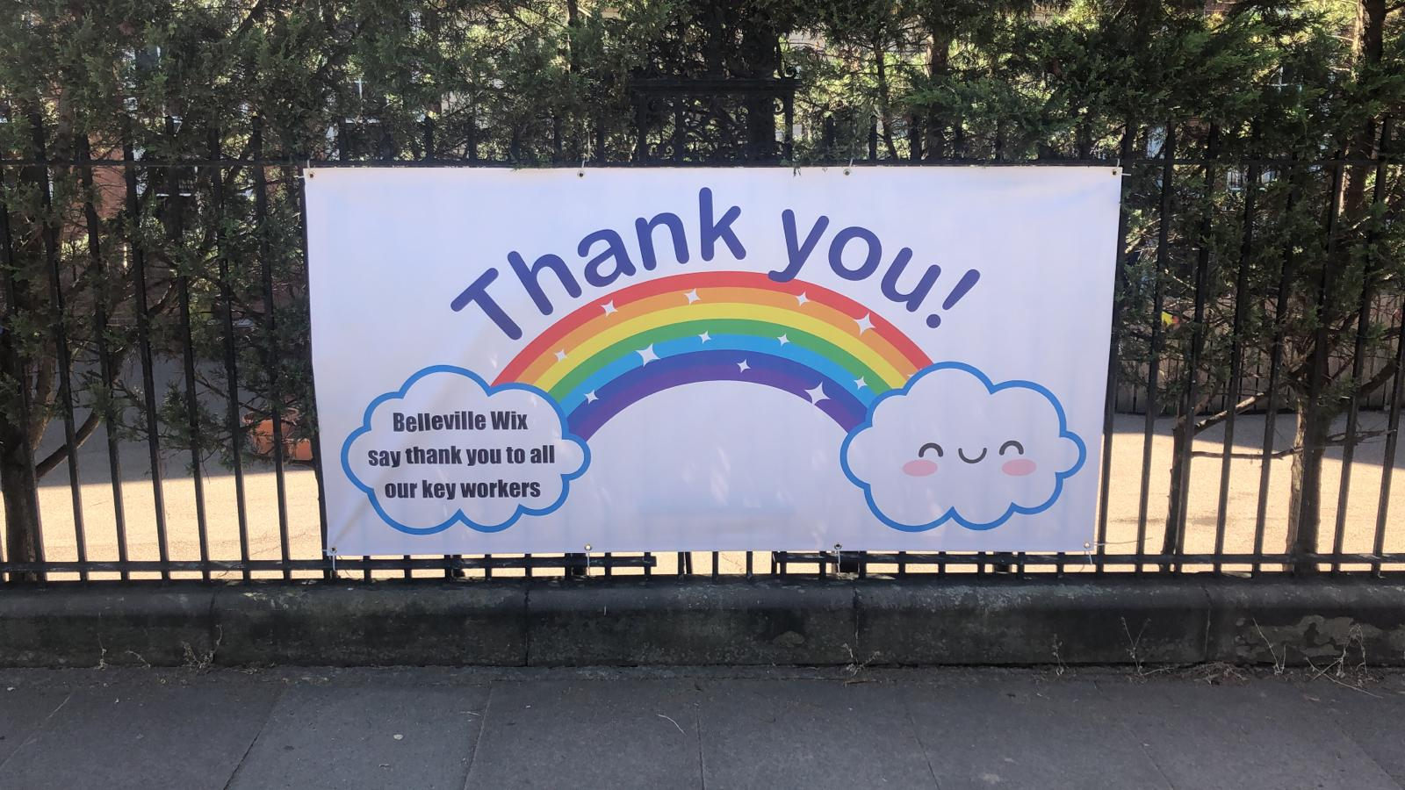

This week we proudly displayed our **Thank You** banner for the Key Workers who are doing all they can to keep us safe. Personally I think you are all heroes – managing so much and within a few months have had to make changes to your lives that you had never dreamed of. As we head into half term, the government’s advice is to stay home as much as possible and stay alert. I hope you all stay safe during the half term and enjoy the glorious weather that is forecast.

**School Staff Video** <https://vimeo.com/421418787>

Our wonderful staff team have a little end of week treat for you! Miss Baker wrote a special poem for our school community and the teachers performed it. We really hope you enjoy it.

**Home Learning** Do enjoy a little rest form home learning this half term. We will not be posting any work for the week ahead. I hope that the extra explanations that were added for each day have been helpful.

We will send the home learning superstar videos to you on the first day back after half term. Teachers tell me it has been another difficult choice. Well done for using the excellent learner traits effectively at home.

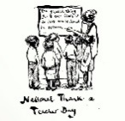**Thank A Teacher Day** On Wednesday our teachers had the most wonderful surprise when the messages you sent in were delivered into their inbox in a video specially created for them.A huge thank you to James Waller who so kindly put all of the messages together in video for each teacher - a mammoth task.

**Dance Challenge** This half term is the perfect time to get practising your dance moves. Please do join in this fun event. We hope it will bring much joy to everyone as we do our best to support each other through this lockdown.

Every family will have received a letter from Mr Grove explaining the Trust decision on opening the school to more pupils. The 8th June is the earliest date a pupil registered at BWA will return to school. Stay safe everyone and have a wonderful half term.

**Miss Henry**

**Headteacher**