Belleville Wix Academy, Wix's Lane, Clapham Common North Side, London , SW4 0AJ

‘The expert in anything was once a beginner.’ Helen Hayes 13th September 2019
To all our new families joining BWA this week, I would like to offer you a very warm welcome to our fabulous school community. On behalf of everyone, we hope that you enjoy being an active member of our flourishing community. For those families who are returning after the summer vacation, we were very excited to see you after the holiday and have loved hearing all about your wonderful experiences.
Everyone gets a little nervous about coming back to school but this soon fades when we reach the school gate and see our friends. On Wednesday morning, I wish I could have shared the inspirational learning behaviours I saw in every classroom, by 9am. Wow! The start to the school year was awesome. Thank you to everyone who made the start of this school year such a sucessful one. We are very fortunate to have a dedicated staff team who care for every child, every day.
During our first assembly last week, we agreed to be awesome after watching the truly inspritational, Kid President. He reminded us of the things we should be doing in school for ourselves , and others. Do look him up if you havent heard of this amazing young person.
Thank you to eveyone who came along last Friday to our first PTA Coffee morning. On the first Friday of every month we have booked in a Coffee Morning. Do pop along, if you can, to meet new friends and build that important support network. Next one is Friday 4th October.
As many of you know, I believe in, and am committed to, working in partnership with you to ensure every child flourishes at BWA. It is important that you know what your children are learning at school and how you can help them. We invited you hear all about the school year and curriculum this week. Thank you to everyone who attended these important sessions. Bilingual and EYFS meetings are scheduled for next week.
This weekend your children will be considering whether to run for School Council. Each class will vote a boy and girl representative. I am sure you will have a great time discusssing this exciting opportunity as well as the commitment that is required. In a few weeks time we will hold elections for our first Eco Council. I am very excited that our children have a voice so they are actively involved in the improvements in our school.
Please may I ask that you ensure there are no nuts or nut products brought on to the school site. We have pupils with severe allergies and need to do all we can to keep eveyone safe. Thank you for your co-operation in our commitment to being a NUTFREE SITE.
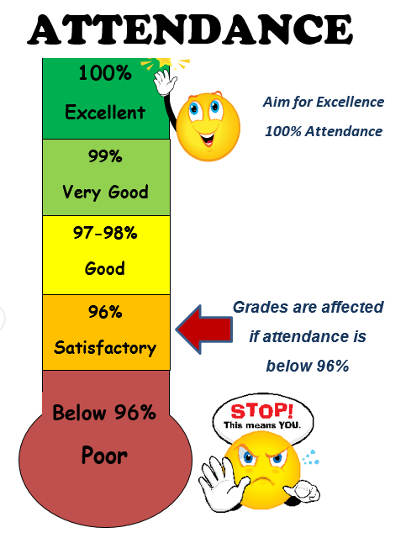
To ensure every child has the best opportunities to flourish, we need them to be in school everyday. This diagram shows the importance of attending school. If there is anything we can do to help you with attendance or punctuality please do not hestiate to ask – we are here to help.

Thank you for the effort you have put into ensuring your children are in school on time at the start of the year and in the correct uniform. If you are unsure of the expectations, the Attendance and Uniform policies are available on the website.

On the back of this newsletter you will find the communicaition table. I hope this will be helpful for you to refer to. It is also available on the school website.

Wishing you a wonderful weekend! Séana Henry
- Half term 21st – 25th Oct
- End of autumn term early finish for English: 19th Dec
- End of autumn term Bilingual: 20th Dec
- Parent Teacher Meeting (English Stream) – 31st October
- PTA Coffee Morning – Friday 4th October
- PTA Wine & Cheese evening Thursday 19th September 7.30pm – 9.00pm
- Reception Curriculum Evening – 18th September 6pm
- Nursery Curriculum Evening – 19th September 6pm
- Bilingual Curriculum meetings - week beg 16th September (see letter last week)

